EFFECTIVENESS OF SMALLHOLDER INDIGENOUS CHICKEN HATCHING SYSTEMS IN SIAYA COUNTY, KENYA

EVANS NADECHO NAKHULO

A THESIS SUBMITTED TO THE SCHOOL OF ENGINEERING IN PARTIAL FULFILLMENT OF THE REQUIREMENTS FOR THE DEGREE OF MASTER OF SCIENCE IN AGRICULTURAL AND BIOSYSTEMS ENGINEERING UNIVERSITY OF ELDORET, KENYA.

2024

DECLARATION

Declaration by the candidate
This thesis is my original work and has not been presented for a degree award in this or any other institution. No part of this thesis may be reproduced without prior written permission from the author and/or University of Eldoret.

___________________________________ Date __________________
Evans Nadecho Nakhulo
SENG/ABE/M/001/20

Declaration by the supervisors
We confirm that this thesis has been submitted with our approval as university supervisors.

___________________________________ Date __________________

Dr. Solomon Adekhela Mulindi
University of Eldoret Kenya

___________________________________ Date __________________

Dr. John Kipketer Langat
University of Eldoret, Kenya

DEDICATION
To my family, whose constant encouragement has driven me to excel in academics and research.

ABSTRACT
Poultry farming in Kenya plays a major role in complementing rural and peri-urban households’ food security and income. Farmers are increasingly shifting to rearing improved indigenous chickens (IC) because of their rapid growth rates and higher egg production. One of the strategies used by development agents in Kenya to enhance growth and meet market demand of IC is to supply day old chicks to producers. However, the demand for day old chicks outstrips supply because of low hatchability experienced in small holder hatcheries. Current study characterized the hatching systems of IC in Siaya County, evaluated and modified the performance of existing hatching systems and evaluated the performance of the adjusted schemes. Baseline survey was conducted on small holder farms and hatcheries to establish the characteristics of hatching systems in Siaya County. The study showed that breeding stocks were reared in enclosed and free-range systems, 55% of the farms attained the standard cock to hen ratio of 1:7 and eggs were stored using both conventional and non-conventional methods. The results further showed that the critical parameters of hatchability were outside the array with a mean hatchability percentage of 56%, Relative humidity (RH) and incubation temperature ranged from 54 to 64%, and from 37.2 to 39.5ºC respectively. This study modified incubating system to; temperature range of 37.1 to 38.5ºC, RH ranged from 56.5 to 62% and evaporative rate of 8.415*10⁻⁵m³/hr. The modified hatching environment yielded mean hatching of 95.3%. A model relating the amount of water to be added in the evaporative pan on a daily basis was developed and evaluated. The results showed that improvement of moisture management in incubators coupled with the physical and physiological management of hatching systems enhanced hatchability to 95.3%. This study provides specific technical modifications that can improve the design and operation of incubation systems, which can then be applied to the development of better hatcheries.

Table of Contents
DECLARATION ii
DEDICATION iii
ABSTRACT iv
LIST OF TABLES viii
LIST OF FIGURES ix
ABBREVIATIONS AND ACRONYMS x
ACKNOWLEDGEMENT xii
CHAPTER ONE 1
INTRODUCTION 1
1.1 Background to the Study 1
1.2 Statement of the Problem 3
1.3 Objectives 4
1.3.1 Broad Objective 4
1.3.2 Specific objectives 5
1.4 Research Questions 5
1.5 Justification and Significance of the Study 5
1.7 Limitations of the Study 7

CHAPTER TWO 8
LITERATURE REVIEW 8
2.1 Introduction …………8
2.2 Theoretical Review …………9
2.2.1 Heat Supply ……….9
2.2.2 Relative Humidity ……..10
2.2.3 Ventilation ……..10
2.2.4 Breeding Stock ……..11
2.2.5 Eggs for Incubation ………13
2.3 Empirical Review ………14
2.3.1 Heat Transfer in the Egg Incubator Systems ……..14
2.3.2 Relative Humidity Distribution in Incubator Systems ……..16
2.3.3 Design Parameters and Performance of Incubator Systems ………17
2.3.3.1 Egg Incubator Temperature 18
2.3.3.2 Incubator Ventilation 18
2.3.3.3 Incubator and Hatchery Tray Requirements 19
2.4 Summary of the Factors Affecting the Process of Incubation 20
2.5 Summary of Literature Review and Research Gaps 21
2.6 Conceptual Framework 25

CHAPTER THREE 27
MATERIALS AND METHODS 27
3.4 Modifying Existing Indigenous Chicken Hatching Systems and evaluating their Performance 33
4.1 Characteristic of Smallholder Chicken Hatching Systems ………37
4.6 Performance of Modified Hatching Systems 64
4.6.2 Hatchability of Hatcheries after Modification 66
CHAPTER FIVE 71
CONCLUSIONS AND RECOMMENDATIONS 71
5.1 Conclusion 71
5.2 Recommendations 71
5.2.2 Recommendations for Further Study 72
REFERENCES 73
APPENDICES 79
Appendix I:Characterization of breeding stocks 79
Appendix II Performance of hatcheries 81
Appendix III: Siaya County Agrovets’ Research Questionaire 87
Appendix IV: Similarity Report 88

LIST OF TABLES
Table 1.1: Poultry population in kenya 3
Table 2.1: Summary of literature review and research gaps 22
Table 4.1: Breeding stock characteristics 37
Table 4.2: Incubator models 46
Table 4.4: Performance of Hatching Machines 53
Table 4.9:Expected hatchability 58
Table 4.12: ANOVA table 63
Table 4.13: Egg turning angle 65
Table A4.1:Breeding stock characteristics 79
Table A4.2: Cocks to hens ratios 80
Table B4.6: Spoilt Eggs 81
Table B4.7: Spoilt eggs from each layer 82
Table B4.8: Features of spoilt eggs 82
Table B4.10: Hatchability under controlled experiment 84
Table B4.11: Water depth and Relative Humidity Regression analysis 84
Table B4.15: Hatchability under controlled experiment 84
Table B4.14:Stocking Hatchability Rating after Modification 85
Table B4.16: Relative Humidity, water depth and temperature values 86
Table B4.17: Depth water levels in the water pan 87

LIST OF FIGURES
Figure 2.1 Incubator ventilation 18
Figure 2.2 Egg hatching basket (www.researchgate.com) 19
Figure 2.3 Egg turning in vertical (A) and horizontal (B) incubators (adapted from Alvarado Mora, 2008) 19
Figure 2.4 Summary of the factors affecting process of incubation 21
Figure 4.1 Proportion of farms cocks to hens’ ratio 38
Figure 4.2 Distribution of number of hens and cocks in different farm 39
Figure 4.3 Distribution of age of hens and cocks 40
Figure 4.4 Comparison of egg tray weight 42
Figure 4.5 Proportion of incubators in various farms 44
Figure 4.6 Mean hatchability percentage 54
Figure 4.7 Status of spoilt eggs 56
Figure 4.9 Relation between Relative humidity and depth of water in the incubator 58
Figure 4.10 Determination of turning angle of egg incubator machines 61
Figure 4.11 Hatchability of hatchery systems after modification 63

ABBREVIATIONS AND ACRONYMS
ASDSP Agricultural Sector Development Support Program
ANOVA Analysis of variance
BeTa Bottom-up Economic Transformation Agenda
CSA Climate smart Agriculture Technologies
CO₂ Carbon dioxide
^{O}C Degrees Celsius
GDP Gross Domestic Product
E Error
IC Indigenous Chicken
KALRO Kenya Agricultural and Livestock Research Organization
KAPAP Kenya Agricultural Productivity and Agribusiness Project
KCSAP Kenya Climate Smart Agriculture Program
O₂ Oxygen
RH Relative Humidity
RMSE Root Mean Square Error
T Temperature
TIMPS Technologies, Innovations, Management and Practices
USAID United States Agency for International Development

ACKNOWLEDGEMENT
I am grateful to God for helping me navigate through all the challenges have faced; His guidance has been evident each day. I extend my heartfelt gratitude to my supervisors, Eng. Dr. Solomon Mulindi and Dr. John Kipketer Langat, whose support made this work possible. Their guidance and advice were invaluable throughout the process of writing and conducting experiments for this thesis. I also want to acknowledge the entire staff of the Department of Agricultural and Biosystems Engineering for their exceptional academic support during my studies.

CHAPTER ONE

INTRODUCTION

1.1 Background to the Study
Agriculture contributes 25-26% of GDP in Kenya with poultry playing a major role, representing 30% of the agricultural contribution to GDP (USAID 2022, Government of Kenya, 2021). Indigenous chicken (Gallus gallus domesticus) contribute 71% of the total egg and poultry meat produced with a population of 42 million birds, of which 82% are indigenous chicken (KALRO 2020).This impacts significantly on the rural trade, welfare and food security of smallholder farmers (Olwande et al., 2010; Republic of Kenya, 2010). White meat is preferred over red meat because of being a source of protein, with a lower fat content hence raising the demand for indigenous chicken (Kim et al., (2017).
Poultry farming contributes significantly to creation of employment to a large number of people, hence; it is a profitable business venture for entrepreneurs. Subsequently, small scale farmers venture in incubators and hatcheries of chicks to meet the growing demand for poultry and poultry products (Lewa and Wahome (2016). In recognition to significance of poultry farming for alleviating household live-hoods, the current poultry development strategy by some county governments in Kenya is to assist rural poor farmers by supplying chicks of improved indigenous chicken breeds to the communities. As noted by Kamau (2018), a suitable strategy has been implemented to enhance poultry productivity. This includes the development and distribution of advanced poultry production technologies, such as improved indigenous chicken ecotypes and fabricated chick brooders, to various smallholder farmers in Makueni and Kakamega Counties by organizations like KAPAP, KALRO, and Techno Serve.

Smallholder indigenous chicken hatcheries in Siaya County exhibit low productivity, primarily due to limited knowledge and skills in poultry production (Njue et al., 2001). Mulindi (2021) points out that the introduction of new technology often brings associated challenges, risks, and issues, which, if unaddressed, can reduce production efficiency. Consequently, new technologies, equipment, and control methods are essential to achieving sustainable development in chicken production.

Kenya’s development blue print, Vision 2030 recognizes the agricultural sector as one of the vehicles that aids the achievements of the targets contained therein. The Kenyan government has prioritized Indigenous chicken in national development priorities 2022- 2028, the six pillars of bottom-up economic model where achieving food security is one of the key areas under Agriculture. Further, Kenyan development agenda has supported micro, small and medium enterprise economy and healthcare. According to Kenya Poultry Farmers’ Association Baseline Survey (2008); farmers with :1 – 1000 birds: are small scale :1001 – 10,000 birds: are medium scale:10,000 and above: are large scale producers.

Kenya has an estimated poultry population of 58 million birds, out of which about 56.8 million (98%) are domestic chickens (SDL, 2020b). Although other poultry types are increasingly becoming important, they are comparatively few (2%) and these include broilers, layers, and others like (ducks, turkey’s, pigeons, ostriches, guinea fowls and quails). Among the domestic chickens, about 46 million (80%) are indigenous or crosses with exotic breeds while the rest are commercial broilers and layers. Therefore, it is important to enhance production of Indigenous or crosses chicken in Kenya. Table 1.1 shows poultry population in Kenya between 2010 and 2019.
Table 1.1: Poultry population in Kenya
YEAR | BROILERS | LAYERS | INDIGENOUS CHICKEN | OTHERS | TOTAL
2010 | 2213750 | 2675571 | 24538906 | 779568 | 30207795
2011 | 2600724 | 2847225 | 26219935 | 684243 | 32352327
2012 | 2847440 | 3076808 | 27967976 | 878991 | 34581507
2013 | 2745188 | 3675425 | 32569198 | 890762 | 39868802
2014 | 4069729 | 3693283 | 33088442 | 909841 | 41742216
2015 | 3117554 | 3716911 | 34666188 | 922181 | 42410494
2016 | 3056747 | 4161289 | 36578441 | 943719 | 44718658
2017 | 3819515 | 4237188 | 40067874 | 1089623 | 49068296
2018 | 4534600 | 5261279 | 42791309 | 1240160 | 53676811
2019 | 4878517 | 5460174 | 46096114 | 909841 | 57674965
 | Adapted from SDL 2020b

1.2 Statement of the Problem
High percentage hatchability of day old chicks ensures the productivity, efficiency and sustainability of poultry farming operations, ultimately contributing to food security, economic development and livelihood improvement in communities worldwide (FAO 2020), The importance of IC in wealth creation and animal protein supply at national and household levels in Kenya has been well recognized (Omondi, (2022).Development and research agencies like ASDSP, KALRO and county governments have come up with interventions in this agriculture subsector - Consequently, the interventions have promoted many small holder farmers to adopt modern methods of egg incubation since natural incubation of eggs rarely fit in conventional chick rearing systems .However, development agents reports indicate a hatchability percentage of 57% in Siaya County. Performance of the smallholders’ hatcheries is low leading to unprofitable ventures by the entrepreneurs in the industry. Some of the incubators used are locally made in informal sector referred to as ‘Juakali’ sector in Kenya with no user manuals making it difficult for effective and optimum setting of favorable parameters for hatching by operators. Similarly, the imported incubators are not calibrated to suite the Kenyan conditions. In addition, low hatchability leads to wastage of energy required to provide microclimate environment for embryo development. Further, the eggs that have been kept in the incubator for 21 days cannot be consumed hence leading to loss of eggs and production time (Onono, (2017). The failure by small holder chicken hatcheries to adequately supply to clients’ day-old chicks contributes to low food production (Kusza (2021). This created a need to evaluate the effectiveness of smallholder indigenous chicken hatching systems in Siaya County, Kenya.

1.3 Objectives

1.3.1 Broad Objective
The broad objective of the study was to evaluate the effectiveness of smallholder indigenous chicken hatching systems in Siaya County

1.3.2 Specific objectives

The study was guided by the following specific objectives;
- To characterize small holder indigenous chicken hatching systems in Siaya County
- To evaluate the performance of existing indigenous chicken hatching systems in Siaya County
- To modify existing indigenous chicken hatching systems and evaluate their performance

1.4 Research Questions
- What are the characteristics of smallholder indigenous chicks hatching systems in Siaya County?
- What is the performance of chicks hatching systems?
- What is the performance of modified chicks hatching systems?

1.5 Justification and Significance of the Study
The demand for chicken products continues to rise due to urbanization, population growth, shrinking agricultural land, and shifting consumer preferences. However, despite this growing demand, output within the chicken value chain remains low, which limits its contribution to economic development (ASDSP 2021). Smallholder poultry systems rely heavily on traditional rearing methods, which are not efficient enough to support high-volume egg incubation. Therefore, there is a pressing need for advanced technologies to improve hatching efficiency.
Kenya's leading agricultural research body, KALRO, is currently managing a World Bank-funded project known as KALRO-KCSAP. This project focuses on specific technologies, innovations, management practices (TIMPS) for the poultry sector, aiming to achieve the Climate Smart Agriculture (CSA) goals: increased productivity, enhanced resilience, and reduced greenhouse gas emissions. This study aligns with the KALRO-KCSAP objectives by enhancing the egg incubation process to boost hatchability and minimize egg wastage, supporting KALRO’s efforts to meet Kenya’s demand for chicken products. Additionally, it supports the government's six-pillar strategy for sustainable food security in Kenya.
The findings and recommendations from this study are anticipated to encourage young farmers to invest in poultry farming with adequate technical skills in incubator management, creating employment opportunities across Kenya. This aligns with Kenya’s Vision 2030 goal of transforming the country into an industrialized, middle-income nation that provides a high quality of life for all by 2030.
At the international level, strategies for bolstering household food security are increasingly recognized. Significant meetings addressing food security include the 2014 International Conference on Nutrition (ICN) focused on core strategies for household food security, the 2020 World Food Summit (WFS) emphasizing the need for food trade policies that support food security, Africa Agenda 2063, and Kenya’s Bottom-Up Economic Transformation Agenda (BeTA), which promotes modern agricultural practices for enhanced productivity and yield.

1.6 Scope of the Study

Egg hatching is influenced by factors such as nutrition, breed type, bird age, egg storage position, incubator temperature, egg turning angle, relative humidity, ventilation, and flock vaccination schedule. This study primarily examined incubation space, temperature, relative humidity, and turning angle. It focused on ASDSP incubators used by farmers, which had various improvements. The study did not consider the mean daily ambient temperature around the hatcheries, as incubators maintain a controlled environment throughout incubation. Eggs were sourced from the same suppliers as the hatcheries. The study concentrated on the improved indigenous chickens commonly raised in Siaya County. Hatchability served as the primary metric for hatchery performance, with temperature and relative humidity in the incubator being key variables studied. Incubation lasted 23 days, but chick quality was not assessed.

1.7 Limitations of the Study
The existing facilities lack the sophistication needed to manage embryonic temperature adequately, and they do not address issues related to in-breeding or the future performance of day-old chicks hatched.

CHAPTER TWO

LITERATURE REVIEW

2.1 Introduction
Microclimate refers to a set of conditions that create the thermal environment within a room (Yasa, 2017). Incubation is the process by which poultry eggs develop into chicks, typically maintained at a constant temperature by the body heat of the brooding parent in many bird species. Humidity is crucial; if the air is too dry, the egg may lose excessive moisture, potentially leading to hatching difficulties. As incubation progresses, eggs typically become lighter, and the airspace inside enlarges due to evaporation (Ramli et al., 2015; Benjamin & Oye, 2012). Therefore, the quality of chicks is greatly influenced by incubation conditions, which play a critical role in the development and future performance of the chicks. Embryo temperature, in particular, significantly impacts both embryonic development and chick quality.
According to Oluyemi and Roberts (1988), an incubator is a mechanical device which controls temperature to around 37.7ºC and humidity creating the ideal conditions which allows the chick to grow inside a fertilized egg, without need for a broody hen. It contains an insulated warm container for hatching eggs and artificially performs the role of a broody hen. It can be made of wood, metal or plastic and contains a heating element, a thermostat to maintain an accurate temperature, egg cradles, water troughs for humidity and in some cases a fan and automatic egg roller or turner. Consequently, a brooder enables large numbers of eggs to be incubated in all seasons.

2.2 Theoretical Review

2.2.1 Heat Supply
Meijerhof (2009) highlights that heat is a crucial micro-environmental factor for incubating chicken eggs, requiring stable maintenance. Lauer (2009) found that the ideal incubation temperature is 37.8°C, although a range between 37°C and 38.9°C is generally acceptable. During incubation, chick embryo development follows two metabolic stages: an endothermic phase starting on day one, followed by an exothermic phase beginning around day nine. According to Roovert-Reijrink (2018), maintaining a constant temperature for developing embryos relies on balancing the embryo's heat needs with heat exchange between the surrounding environment and the egg, which is affected by humidity, ventilation, and air movement.
Van der Pol et al. (2013) emphasize that incubator designs must have adequate warming capacity for the early incubation days (up to day nine) and cooling capacity afterward, as embryonic heat production increases. Any drop-in temperature below 35.6°C or a rise above 39.4°C for more than an hour after incubation starts can lead to embryo death. If temperatures stay outside the egg's thermal neutral zone, hatching failure is likely. High temperatures are particularly critical, as they can result in embryo mortality, while lower temperatures slow development, delaying hatching (Preez, 2007; Lourens et al., 2005).
Servet (2022) concludes that the ideal continuous incubation temperature for poultry species lies between 37°C and 38°C, though hatching is possible between 35°C and 40.5°C. Egg embryos are generally more susceptible to higher temperatures than lower ones; the impact of suboptimal temperatures depends on both the deviation from the ideal and the duration of exposure. Furthermore, embryos tend to be more vulnerable to non-optimal temperatures at the start of incubation than late.

2.2.2 Relative Humidity
Molenaar et al. (2010) stated that approximately 14% of the initial weight of an egg must be lost as water vapor to form an air space large enough to facilitate pulmonary respiration. The optimal relative humidity (RH) for incubating chicken eggs has been identified as 40-70%, with the highest hatching rates occurring at around 50% (Bruzual et al., 2000a). Van der Pol et al. (2013) found that maintaining RH between 55-60% and a constant temperature of 37.8°C during incubation maximizes hatchability. Extremes in RH are harmful to embryo development, leading to poor hatch rates due to dehydration or over-hydration. Low RH causes dehydration, producing chicks with lower body weights and, in some cases, causes embryos to adhere to the eggshell membrane, complicating the hatching process (Van der Pol et al., 2013). On the other hand, overly moist incubator conditions prevent sufficient water loss, causing chick edema during development. This lack of adequate weight loss can result in poor hatch rates due to unsealed navels (Bruzual et al., 2000b)

2.2.3 Ventilation
Ventilation is essential in maintaining optimal incubation conditions for temperature, humidity, and the ideal CO₂-to-O₂ ratio, which supports optimal embryo development (Green, 2014). In nature, the movements of a broody hen and the fluffiness of her abdominal feathers provide natural ventilation to promote airflow. In artificial incubation, ventilation has two key aspects: the ventilation in the hatchery room, which is adjusted to create a uniform environment as per manufacturer specifications and environmental variations, and the ventilation within the incubator’s setter and hatcher, which is crucial for supporting successful embryo growth. The airflow rate over the incubating eggs should ideally be around 0.33980 m³/min, utilizing natural air with typical oxygen and carbon dioxide levels of 20-21% and 0.4%, respectively (Clauer, 2009). Airflow speed is particularly important during the poikilothermic phase when warmth is essential, and during the exothermic phase, where embryos generate significant heat that must be dissipated. Insufficient air velocity can lead to uneven cooling, with eggs in lower trays receiving less cooling than those in upper trays, resulting in uneven heat distribution (Elibol & Brake, 2008). Lack of ventilation, similar to low RH, can reduce weight loss (Fares et al., 2012). Research indicates that controlling CO₂ levels during incubation can be advantageous; gradually increasing CO₂ to 1.5% during the poikilothermic phase has been found to enhance embryo growth and development, accelerate chick emergence, and improve hatch rates (Tona et al., 2007; De Smit et al., 2006).
2.2.4 Breeding Stock
Cheng (2010) describes breeding stock as the group of male and female chickens that serve as the parent generation for future birds. They need a balanced diet to sufficiently meet the nutritional needs of embryos. The productivity of Indigenous Chickens (IC), like any livestock, depends on both genetics and environmental factors, influencing their ability to produce fertile, hatchable eggs and adapt to changing environmental conditions such as temperature, humidity, nutrition, pests, and diseases. Kenyan IC are often named after the regions where they are found, known as ecotypes, which include Narok, Bomet, Bondo, Kakamega, West Pokot, Lamu, and Taita-Taveta (Okeno et al., 2012; Magothe et al., 2010). Additionally, naming is influenced by observable physical traits, reflecting their adaptive genetic characteristics, which can be classified into categories such as feather density, body size, and plumage color (Sorensen, 2010).
Birds are further grouped by these phenotypic traits into categories like naked neck, frizzled feathered, feathered shanks, normal feathered, and crested head, as well as size variations such as dwarf or giant (Okeno et al., 2012). They are also categorized by color, including black, white, brown, or mottled (Ngeno, 2011; Dessie et al., 2003). Kenyan IC exhibit diverse genotypes, expressed through combinations of traits that allow adaptation to various environments. For instance, the naked neck and frizzled feather types perform better in hotter climates due to their lighter body cover, which facilitates heat dissipation, unlike the fully feathered types (Ngeno et al., 2014; El-Gendy et al., 2007). In colder, high-altitude areas, the normal-feathered, crested head, feathered shank, and bearded types are more common (Njenga, 2005).
Phenotypically, Kenyan IC show distinct morphological groups that correspond with variations in adaptability, reproduction, and productivity (Okeno et al., 2012; King’ori et al., 2010). Genetically, IC can be classified into two main groups: molecular characterization has clustered them into four regions—Northern, Western, Central, and Coastal Kenya (Mwacharo et al., 2007). Using microsatellite DNA markers, Mwacharo et al. (2013) further categorized them into Eastern (Marsabit, Meru, Kitui, Muranga, Kilifi, and Taita-Taveta) and Western (Kakamega, Homa Bay, Kisii, and Nandi) groups. Indigenous chickens with NN and FF genetic markers are associated with faster growth, larger body size, greater clutch size, and resilience against diseases (Islam & Nishibori, 2009)."

2.2.5 Eggs for Incubation
The primary factors influencing the fertility and hatchability of Indigenous Chicken (IC) eggs include breed line, age, mating practices, health, egg quality, and storage. Non-genetic factors tend to have a greater effect on heritability, with fertility and hatchability heritability ranging from 0.6 to 0.13 (Sapp et al., 2004). Fertility rates are generally higher in lighter breeds than in heavier ones, although hatchability is not significantly affected by IC breed line (Islam et al., 2002). Bird age impacts fertility, which typically rises to a peak before declining; this trend is more pronounced in hens than in roosters (Brotherstone et al., 2000; Brommer & Rattiste, 2008). Mating practices influence egg fertility, as eggs generally become fertile around four days after introducing a fertile male to hens. An optimal cock-to-hen ratio is essential to maintain consistent egg fertility, with ratios typically ranging from 1:5 to 1:10 depending on the production system, being higher for heavier breeds and free-range setups than for lighter breeds in confined systems (Kompi, 2015).
Egg quality is categorized into two main groups: external and internal quality characteristics (Nonga et al., 2010; Fayeye et al., 2005; Monira et al., 2003). According to Bain (2005), external quality features include size (volume and mass), shape index (measuring width-to-length ratio), shell thickness, shell color, and shell porosity, while internal quality characteristics involve albumen, yolk, and blastoderm size, all of which influence the embryo's viability (Onagbesan et al., 2007).

2.3 Empirical Review

2.3.1 Heat Transfer in the Egg Incubator Systems
Heat transfer happens when there is a temperature difference between two areas or materials. Eggs use three heat transfer mechanisms: conduction, radiation, and convection (Morita, 2016). Heat is gained or lost by the egg only when the eggshell’s temperature differs from the surrounding environment, and this process is influenced by factors like breeder age, egg size, composition, shape, shell characteristics, as well as water loss and incubation conditions. Each gram of water lost through evaporation results in a heat loss of 2.26 kJ, cooling the eggshell in the process (Meijerhof, 2013). This cooling effect is key to understanding heat loss by conduction. Water diffuses through the eggshell due to differences in water pressure between the inside and outside of the egg, depending on the temperature and relative humidity on both sides. The rate of water loss is influenced by eggshell porosity, which depends on factors such as pore count, egg diameter, length, and shape (Deeming, 2002). Consequently, eggs from older breeders or larger eggs from breeders of the same age tend to lose more water, particularly under high temperatures or low humidity (Sgavioli et al., 2015; Morita et al., 2009). In artificial incubators, fans are essential for distributing heat throughout the system.
During incubation, water in the egg is absorbed by the developing embryo from structures like the amniotic cavity, allantois, and yolk sac (Ar, 2004), though a small portion of water is lost to the environment. Additionally, metabolic water produced by lipid metabolism in the embryo, especially during the last week of incubation, contributes 8-13% to the embryo's water content (Boerjan, 2006). The thermal energetics of incubation was modeled by Meijerhof (2013) and van Beek (2000). A simple form of the model given as:
T_{egg} =T_{inc} + (H_{emb} –H_{water loss})/K………………………………………2.1
Where
T_{egg} = temperature of the egg (º Celsius)
T_{inc} =temperature of incubator (º Celsius)
H_{emb}= heat production of embryo at a given moment of incubation (Watts);
H_{water loss}= heat loss from evaporative cooling (Watts);
K = thermal conductance of egg and surrounding boundary of air around the egg (Watts per degree Celsius).
The heat balance of an animal is described by (Gaughan 2009)
H_{emb} = H_{water loss}± H_{rad} ±H_{conv}
or rewritten
H_{emb} – H_{water loss}= H_{rad} +H_{conv} ……………………………………….2.12
The equation includes the term H_{waterloss} because eggs consistently lose water throughout incubation, typically about 12% of the egg's initial weight from the start of incubation until the beginning of piping (Ar, 2004). The transition from liquid water to water vapor requires heat, which at incubation temperatures is around 580 calories per gram of water lost.
At the onset of incubation, H_{emb} is negligible and therefore T_{egg} <T_{inc} because H_{emb} <H_{water loss}. However, at the end of incubation, H_{emb} >> H_{water loss} and therefore T_{egg} >T_{inc}.H_{emb} and H_{water}).H_{emb} was observed to exceed H_{water loss} midway through the incubation period. Direct measurements of T_{egg} have also observed that it exceeds T_{inc} midway through incubation in both chicken (Emilia, 2022) and turkeys. The result is that during the first half of incubation, eggs will be gaining heat from the surrounding air, whereas during the second half of incubation, eggs will lose heat. The thermal conductivity term, K, used in Equation combines the thermal conductivity of the egg (K_{egg}) and the boundary layer of air around the egg (K_{air}).
Bahrami 2004 determined values for K_{egg} and K_{air} and showed that the air boundary layer around the egg was approximately 100´greater a barrier to heat loss than the egg itself. These authors also showed that the value of K_{air} is dependent on the air speed over the eggs and the relationship could be estimated as follows
K = (0.97 U^{0.6}) M^{0.53}…………………………………………………….2.2
Where U = air speed (centimeters per second)
M = egg mass (grams).
The effect of changing air speed from 0 to 100 or 400 m/s increased thermal conductance by approximately 2.5´ and 6´, respectively.

2.3.2 Relative Humidity Distribution in Incubator Systems
Eggshells are porous, allowing water to pass through, so all eggs gradually lose water over time, whether incubated or not. The rate of water loss during incubation is influenced by the humidity inside the incubator: higher humidity levels slow down water loss, while lower levels accelerate it. Each egg contains an air space at its rounded end that grows as water escapes and air replaces it, with the air space expanding proportionally to the water loss (Chesoo et al., 2021; Young et al., 2013).
This air space is essential during incubation, providing the first breath for the fully developed chick and giving it room to move and position itself for hatching. If humidity has been too high, the egg loses insufficient moisture, causing the chick to grow too large for the available air space. In such cases, the restricted space affects the chick’s breathing and makes it difficult to break out of the shell. High humidity levels often result in chicks dying after making a single break in the shell due to limited space for further movement or insufficient air supply (Omondi, 2020).
Additionally, pressure within the egg may cause the chick’s beak to protrude from the initial opening, disrupting the usual anti-clockwise chipping of the shell from the inside and leading to drying mucus clogging the beak. Conversely, low humidity leads to smaller chicks with larger air spaces by hatching time, which can result in weak chicks that may not survive the hatching process. Generally, slightly lower-than-optimal humidity is less harmful than a higher-than-ideal level (Divoky & Harter, 2010).
The studies primarily explore how high and low humidity levels impact chick development during incubation, though they do not delve into the factors causing low humidity variations or offer remedies to avoid reaching critical humidity levels.

2.3.3 Design Parameters and Performance of Incubator Systems
Ross (2010) highlights that the primary factors impacting chicken development are in-house conditions, with ambient temperature, relative humidity, and air movement within the broiler house being particularly critical. Likewise, when designing incubators for indigenous chicken, it’s essential to ensure optimal temperature, humidity, and air circulation within the incubation space, along with other key factors.

2.3.3.1 Egg Incubator Temperature
Optimum incubation temperature is defined as that required to achieve maximum hatchability. However, Hammond 2009, argued that the quality of the hatchling should also be considered. The incubator temperature influences the duration of incubation and the rate of embryo growth (Gener 2003). Incubation temperature has been found to affect the hatchling’s thermoregulatory ability, hormone levels, and post hatching growth rate. According to Ann Goth 2004, temperature may alter the sex ratio by altering the phenotype sex of a proportion of chick embryos; this factor is of greater commercial importance.
Recent studies by Ipek 2015, suggest that optimum temperature may differ between poultry strains or eggs of different size. Interpretation of incubator temperature studies is difficult because they use incubator operation temperature as the temperature treatment applied to the egg. The data from both chicken and turkey incubators show that the temperature indicated on the incubator control may be significantly different from the temperature of the air surrounding the egg. (Kamau et al., (2018), Okeno et al., (2012,)

2.3.3.2 Incubator Ventilation
Ventilation is the process of supplying fresh air to an enclosed space in order to refresh the existing atmosphere needed to regulate temperature and remove moisture, dust, odours carbon dioxide, ammonia, and other gases as shown in Figure 2.1. According to Fairchild (2012), air must be introduced uniformly, mixed well with incubator air, and circulated properly. Miles (2004), affirm increased ventilation reduces contaminant load inside the incubator but compromises energy efficiency.
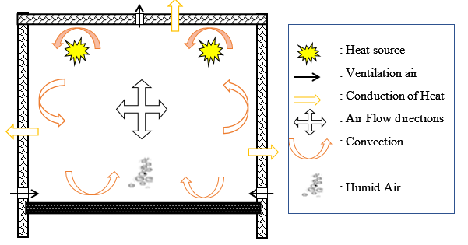
Figure 2.1 Incubator ventilation
Source: www.researchgate.net

2.3.3.3 Incubator and Hatchery Tray Requirements

Hatch trays are specifically designed to hold eggs securely during incubation. They prevent contact between the eggs and the damp substrate within the incubation box and keep the eggs from moving around, especially during the turning process in automatic egg incubators. Figures 2.2 and 2.3 illustrate two types of trays used for egg storage.

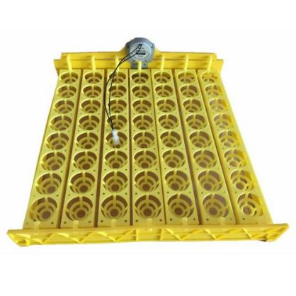
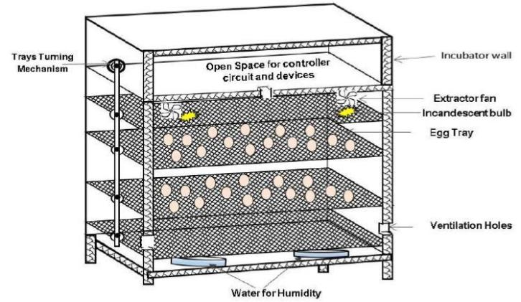
Figure 2.2 Egg hatching basket (www.researchgate.com)
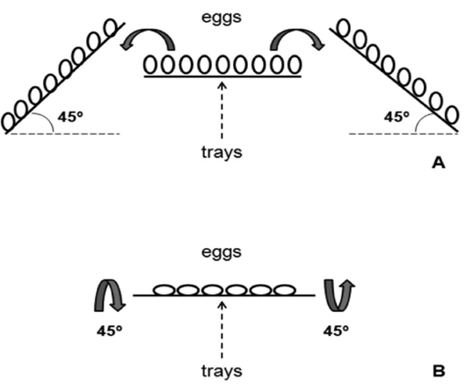
Figure 2.3 Egg turning in vertical (A) and horizontal (B) incubators (adapted from Alvarado Mora, 2008)

2.4 Summary of the Factors Affecting the Process of Incubation
The most influential egg parameters that affect hatchability are: weight, shell thickness and porosity, shape index and the consistency of the contents. Heat stress reduces the external and internal egg qualities and affects all phases of semen production in breeder cocks.
Breeder factors include strain, health, nutrition and age of the flock, egg size, egg storage duration and conditions. Figure 2.5 summarizes the factors that affect hatching of eggs.
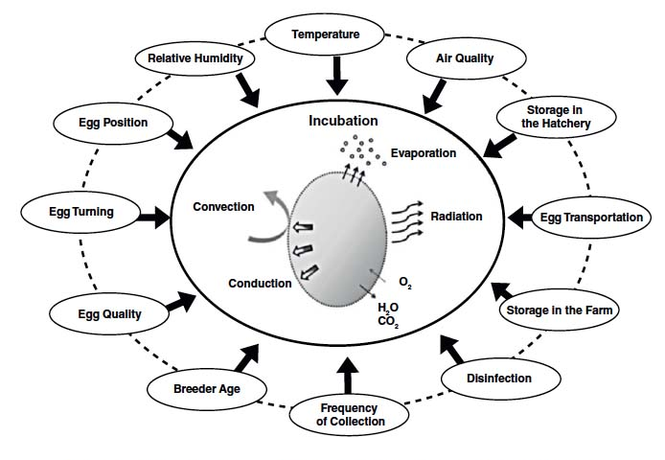
Figure 2.4 Summary of the factors affecting process of incubation
Source: zootecnicainternational.com

2.5 Summary of Literature Review and Research Gaps
There are previous researches on egg incubation which have addressed various challenges in egg incubation but still not improving the productivity of Indigenous Chicken (IC), Table 2.1 shows the summary of important research covered in this study, critiques of the same and identified research gaps;
Table 2.1: Summary of literature review and research gaps
S/No | Author(s) | Title | Critique and research gaps
 | Theoretical review
1 | Phiri et al (2007), Pederson (2002) | Hedonic price analysis to guide in breeding and production of Indigenous chicken in Kenya | The study concentrated on low-input systems in rural areas and the prevalent preference for indigenous poultry meat and eggs. However, it did not explore the reasons why the supply of indigenous chickens falls short of meeting market demand.
2 | Ondwasy et al., (2006), Seidler and Martin, (2003) | Indigenous chicken  Production manual-Kenya Agricultural Institute Technical Note Series. | The studies focused on using  Indigenous chicken meat over red meat raising the demand but did not discuss how the production of white meat should be enhanced
3 | Okitoi and Mukisira (2001) | Indigenous chicken production in Kenya | This study highlights the past improvement attempts and suggests strategies to improve IC productivity but did not discuss hatching systems management as one of the ways of improving IC productivity

 |  | Empirical review
 | 4 | National Poultry Technology Centre- NPTC (2014), Auburn University |  |  | Managing Heat and Minimum Ventilation Systems in the Broiler House |  | The researchers asserted that proper temperatures for raising chicks and eggs can vary according to individual flock requirements. The recommended brooding temperatures discussed in the study were based on studies Conducted on broiler chicken. Therefore, there is need to conduct studies to identify appropriate temperatures for brooding indigenous chicken.
 | 5 | Divoky, Harter, (2010). |  |  | Supernormal Delay in Hatching, Embryo Cold Tolerance and Egg fostering |  | From the study, slightly lower humidity level than optimum is likely to be less disastrous than a slightly higher than ideal level. The authors have note expressly stated the optimal RH range.
 | 6 | Hammond et al., (2007) |  |  | Effects of incubation temperature on incubation of broilers |  | This study suggests that the ideal incubation temperature may vary across poultry strains. Consequently, it is essential to establish the optimum temperature and egg size to enhance indigenous chicken production.
 | 7 | Njenga (2005) |  |  | Assessing the productivity of indigenous chickens in an extensive management system in Southern Nyanza, Kenya |  | The study focused on how low performance of hatcheries has led to low food production and productivity in Southern Nyanza of Kenya. The study did not investigate the causes behind low performance of hatcheries
 | 7 | Lemaire, (2005) |  |  | Quantification of the heat exchange of chicken eggs |  | The study focused on determination of the heat transfer between the eggshell and its microenvironment but did not discuss the optimum egg shell hardness temperature and evaporation rate for hatchability
8 |  |  | Fasenko et al., (2001b) | The effect of pre storage incubation on hatchability |  | The study focuses on the stage of embryonic development after pre storage incubation. The pre storage duration not established for indigenous chicken used in smallholder hatcheries

2.6 Conceptual Framework
A conceptual framework connects independent variables to dependent variables, taking into account factors like moderating and intervening variables (Bryman and Bell, 2011). It serves as an analytical tool adaptable to various contexts and types of work where a comprehensive overview is required. This framework helps in making conceptual distinctions and organizing ideas. Figure 2.5 illustrates the conceptual framework used in this study.
Characterization of hatching systems
- Features of breeding stocks
- Model of hatchery
- Physiological management of incubators
- Physical management of incubators
Evaluation of performance of existing hatching systems
- Appraisal of hatchability of the eggs
- Temperature management
- RH humidity management
- Turning angle of eggs
Modification and evaluated performance of hatching systems
- Optimum incubating hygiene parameters
- Optimum breeding factors
- Optimum egg management
- Setting temperature
- setting relative humidity
- Setting turning angle
- Modeling of temperature and relative humidity

Effectiveness of hatching systems
- Hatchability of the eggs

Figure 2.5 Conceptual framework

CHAPTER THREE

MATERIALS AND METHODS

3.1 Study County
This study was carried out in Siaya County with a group of farmers under the Agricultural Development Support Program (ADSP) chicken value chain; a World Bank supported Program. The county lies between latitude 0° 26’ to 0° 18’ North and longitude 33° 58’ East and 34° 33’ West and 20km South of the Equator with an average temperature of 21.4ºC. Figure 3.1 is the map of Siaya County showing the location of chicken hatcheries in the county.
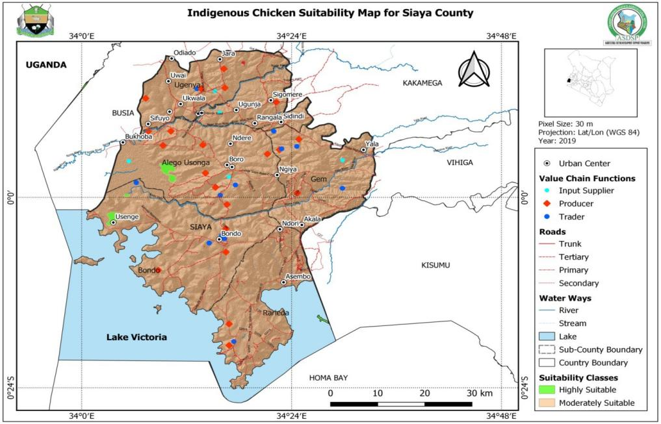
Figure 3.1 Location of hatcheries in Siaya county, source: https://asdp.kilimo.go.ke
The study was carried out in collaboration with Siaya county ASDSP and Climate Smart Agriculture Program,
Administratively, Siaya County is divided into six sub counties; namely, Alego Usonga, Gem, Rarieda, Bondo, Ugenya and Ugunja. Indigenous poultry production is carried out in all the sub counties as a semi commercial venture.
3.2 Characterizing of Small holder Indigenous Chicken Hatching Systems
In this study, 20 farms were mapped out that were still under operation out of which the sampling size was taken as 50% plus one (11; A systematic sampling method was used to select the farms to be studied with a sampling interval of k^{th} value computed using equation (3.1) where N and n are number of farms and sampling size respectively. The farms were listed according to surname and every odd number farm was selected for the study. The sampling of 11 farms was distributed across the county.
K =N/n………………………………………………………………….……3.1
The factors considered during characterization include; types of breeding stocks, handling and storage of eggs, management of hatching units and the designs of egg incubators. It was noted the farms were supplying the market with day old chicks within the county.
3.2.1 Breeding Stocks
During farm visits, both primary and secondary data were collected. Secondary data was obtained from records of previous rearing batches, while primary data came from the batch present on the farm at the time of the visit. The data were collected and verified through physical counts of hens and cocks during the visits, with records made accordingly. Additionally, a survey of agro-veterinary stores in the county was conducted by randomly sampling businesses to identify the types of vaccines stocked, based on the sample questionnaire in Appendix C. Key characteristics in this study included breed types, cock-to-hen ratio, rearing method, and age of hens and cocks.
3.2.2 Handling and Storage of Eggs
The egg characteristics affecting hatchability that were examined included storage position, storage duration after laying, storage equipment, cleanliness, size, and weight. Eggs were selected from the bulk volume on each farm to minimize variations, ensuring that their dimensions aligned with Stern’s (2001) standards. This standardization was essential for consistent comparisons and predictions. Sampling was conducted by taking three (3) trays of eggs from each farm, serializing the eggs from one to ninety, and selecting every even-numbered egg for study. Egg mass was measured with a SAB-200E electronic balance to the nearest 0.001g. Equation 3.1, based on the arithmetic sequence formula, was used to confirm the accuracy of the total number of eggs sampled
P_{o} = (P₁ – P₂-1)/2………………………………………………………………………3.1
Where
P_{o} = Total even number
P₁= Last number
P₂ = First number

3.2.3 Incubator Models
The incubators on all the sampled farms were inspected to ascertain their models, egg capacity, and source of power, position of fans, water basin design and models. Figure 3.2 shows components of a 700-egg capacity incubator that were of interest in this study. The data was recorded and analyzed.
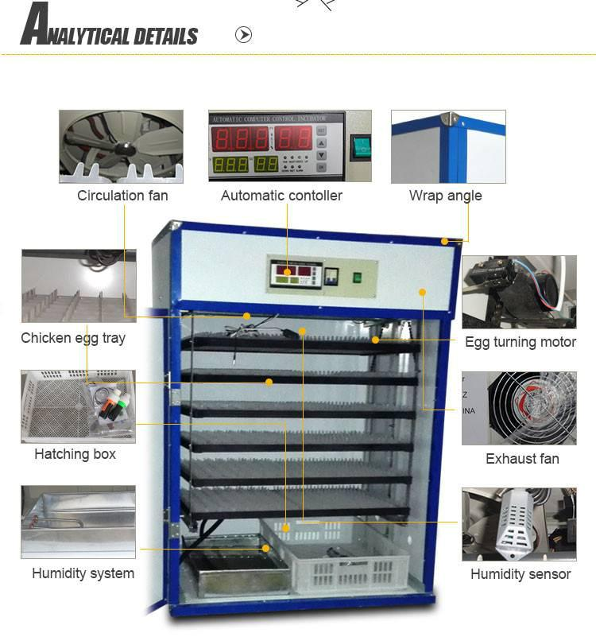

Figure 3.2 Components of 700 egg capacity incubator
Source: www.nicehatchicubators.com
3.2.4 Management of Hatching Units
Management of hatching units on the 11 farms were monitored for 30 days and data recorded. In the study, observations were done on management practices for five (5) days before loading the incubators and five (5) days after hatching for hatchery operation controls. The parameters considered included: preparation of incubators before loading eggs, day of removal of chicks from incubators, frequency of adding water to the incubator water pan and the depth of water in the water pan, method of housing the egg incubators and existence of thermometer and relative humidity meters in the machines, handling of day old chicks, after removing from the hatchery, packaging and the transport arrangements to the potential customers .Figures 3.3 and 3.4 shows temperature and RH indicators and egg incubator trays respectively.
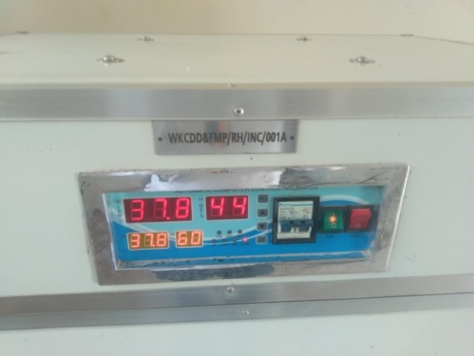
Figure 3.3 Machine control unit showing temperature and relative humidity during incubation
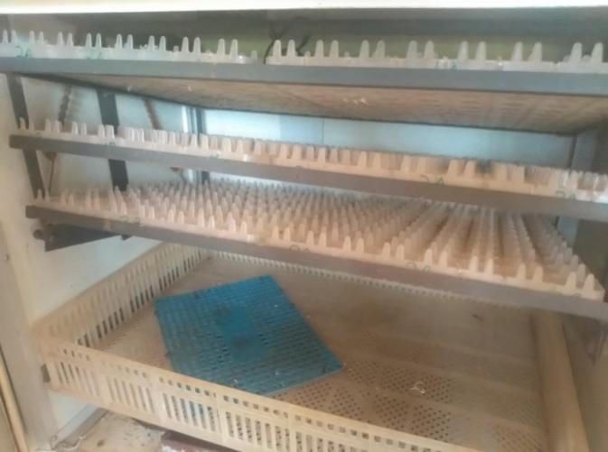
Figure 3.4 Combined egg incubator trays with a hatcher at the bottom
3.2.5 Data Analysis and Presentation
Bar graphs and pie charts were used to present and analyzed the data collected.
  - Evaluating the Performance of Existing Indigenous Chicken Hatching Systems
The performance of indigenous chicken hatching systems was assessed across 11 hatcheries through a two-phase study. In the first phase, data from the past three batches were reviewed, recording key performance metrics for analysis. The evaluation criterion was the hatch percentage of eggs stocked in each hatchery across these batches. Data collected for each hatchery included incubator capacity, number of eggs stocked per batch, and number of chicks hatched per batch. The percentage hatch rate per batch was calculated, followed by the average performance per hatchery, and a county-wide performance overview was derived. Additionally, the root mean square error (RMSE) was calculated for sensitivity to significant errors.
In the second phase, validation of secondary data was conducted by replicating farmer practices in the hatcheries. This process involved selecting eggs, recording the stocked eggs, monitoring temperature and relative humidity, filling water basins, and standardizing general hatchery management. The incubation period lasted 23 days, with uniform disinfection and setup procedures across all hatcheries. The study took place from May to October 2022, with all parameters such as temperature, humidity, and water basin levels maintained throughout. On the 23rd incubation day, chicks were counted, and unhatched eggs were examined to determine developmental issues, including dead, underdeveloped, and rotten eggs.
Alongside the 11 hatcheries, a control study was conducted using a 128-egg incubator with automatic temperature and humidity controls, ranging between 37.1 to 38.5°C and 60 to 75% humidity. Eggs for the control study were selected based on farmer practices and sourced from the same batches as the 11 hatcheries. Hatch counts and data were recorded for comparison.

Modifying Existing Indigenous Chicken Hatching Systems and evaluating their Performance
The results obtained from the experimental setup using farmers’ practices on the 11 study farms were not satisfactory due to the low performance of the hatcheries. Therefore, there was need to undertake further investigation to establish causes of low hatching in farmers’ hatcheries. Detail studies were effected using a smaller sample drawn from the eleven farms.
According to Ryan, (2020) when studies are carried out on small size populations the minimum representative sample size should be 30% of the population. This study adopted 30% sample size of the eleven (11) farms under previous studies resulting to 3.66 hatcheries. However, rounding it off gives 4 hatcheries but Mumtaz and Memon, (2020) averred that even sample sizes lead to slightly different levels of precision in estimates compared to odd sample sizes when calculating margins of error and confidence intervals. This scenario could affect the reliability and robustness of research findings, especially in studies with small sample sizes. Subsequently, in this study a sample of three (3) hatcheries was adopted and the three (3) farms that recorded the lowest hatching percentages in the previous study were selected for modifications and detailed incubation study.
Modifications of the hatching systems were done based on empirical studies and standard procedures that had given good hatching results in other studies. According to Brommer, (2008) optimum age for hens to lay eggs for incubation is between 24 to 216 weeks, the study adopted eggs from hens of age 36 weeks. Moreki (2009) averred that fertile eggs should be stored for 3 to 10 days and this study embraced eggs stored for duration of 3 to 5 days. The study Rocha, (2021) approved the recommendation of storing eggs with the thin tip down, Mungube et al., (2008) noted that optimum incubating hygiene prevents spread of the disease-causing microbes. Accordingly, the incubators were cleaned and fumigated after every stocking; In addition, the recommendations of Ernst, (2017) were adopted where setting and hatching temperature were fixed at 37.4ºC and RH at 55% for the first 17 days and 65% for the last 3 days. Eggs were collected from farms where the Cock to hen ratio were within the acceptable ratio of 1:7. Setter tray turning angle was set at 45º and water pan depth was modified to be refilled at regular interval to allow for evaporation to attain optimum RH in the brooding chamber.
The eggs were loaded in the incubators for 23 days and percentage hatchability recorded. This set up was replicated three times. The setter egg trays were calibrated in two stages; when empty and when loaded with eggs to ensure the correct turning angle was achieved. Each machine setter tray was fixed at angle of 45º with one-hour full turn and 5 minutes for the level period. A total of 5191 eggs were incubated as per the capacities of the incubators for three (3) replications.
In addition, a control experiment was set up and the hatching systems were made as per the recommended standards; the eggs were collected from hens of between 24 to 216 weeks age. The eggs were of relatively same size, duration of egg storage was between 1 to 5 days, and the cock to hen ratio was 1:7. Hatchery temperature was fixed at 37.4ºC and RH at 55% for the first 17 days and 65% after transferring eggs from the incubator to the hatchery. After 23 days of incubation, hatched chicks were counted and results recorded accordingly.
In this study, stand by generators were used on all the three firms to ensure stability of power supply throughout the incubation period. The evaporating pan measuring 0.3m by 0.3m by 0.1m was filled after every 24 hours with the initial and final depth of water levels being recorded. The data collected for water depth values were used to determine the daily volume of water to be added in the evaporating pan after every 24 hours to achieve the recommended RH within the incubating space. The results of the modified hatching systems were recorded and compared with the farmers’ practices in the county.
Further, the study established the relationship between temperature and relative humidity in the incubating chamber. A general form of the regression model as shown in equation 3.3 was adopted for moisture regulation in the hatching chamber (Muhsin, 2017; Flinger, 2013; Khadr, 2008). In the equation, Y is temperature (ºC); a is y-axis intercept (constant); x₁ is relative humidity (%); x₂ is depth (cm); b and c are coefficients of the variables.
Y = a + bx₁+ cx₂.......................................................................................... 3.3
Based on this basic model, a mathematical model was developed to determine the volume of water to be added in the water pan after every 24 hours for effective evaporation rate that will maintain the RH at optimum.

CHAPTER FOUR
RESULTS AND DISCUSSION

4.1 Characteristic of Smallholder Chicken Hatching Systems
4.1.1 Breeding Stocks Rearing Systems
From the results shown in Table 4.1 and Appendix A4.1, it is revealed that Sasso kuroiler, kenbro and KALRO improved chicken are the three (3) breeds of the improved indigenous chicken raised on hatchery farms in Siaya County. According to Mahindra, (2016) chicken breeds adaptable to harsh environmental conditions and tolerant to poultry diseases are preferred by most farmers. In addition, studies by Njenga (2005), Kardia and Kitalyi (2002) and Juma and Ondwassy (2002), attributes the popularity of these breeds among the farmers to laying more eggs than ordinary indigenous breeds. Lastly, Magothe et al., (2010) and Siamba et al., (2002), avers that Sasso kuroiler, kenbro and KALRO breeds have fast maturity owing to improved characteristics. The fast growth disease resistance and good environmental adaptability as observed by various authors are likely to be influencing factors to the popularity of three breeds of improved indigenous chicken reared in Siaya County.

Table 4.1: Breeding stock characteristics
Parameter/Farms | Maningi | Sidindi | Obwombe | Wagai | Mwezi Solar
Breed type | sasso kuroiler | sasso kuroiler,kenbro,kari improved chicken | sasso kuroiler | sasso kuroiler | sasso kuroiler,kari improved chicken
Sub county | Rarieda | Ugunja | Gem | Gem | Gem
Rearing regime | Enclosed | free range | enclosed | free range | free range

Omuma | Blood sister | Spio | Dala Riek | Dijos | Maugo
sasso kuroiler | sasso kuroiler | sasso kuroiler | sasso kuroiler | sasso kuroiler | sasso kuroiler,kenbro
Alego | Alego | Bondo | Bondo | Ugenya | Ugunja
enclosed | free range | enclosed | enclosed | free range | free range

Investigation of the poultry rearing regimes showed that the breeding stocks are either reared as free range or enclosed systems. Results of this study are presented in Figure 4.1 and in Table A4.2 in the appendices. The farms have adopted two (2) types of rearing régimes: enclosed system where by the hens and cocks have been confined in one place where the breeding stocks mingle freely in a house set up, It was observed that 60% of the farms that practice enclosed system have poultry that are within the required ratios while 33% of the farms in free range system are within the required ratios with minimal deviations from the recommended ratio of 1:7.The ratio of cocks to hens in a free range system ranged from 1:3 to 1:6 while in an enclosed system the ratio was relatively uniform of 1:7. Hence there are instances of ratio falling outside the required limits. Molapo & Kompi, (2015) and Oluwaseun ,(2020) recommended that in a free range system the ratio of cocks to hens should be 1:4 while enclosed range system the ratio to be 1:7. According to Alsobayel and Albadry, (2012), chickens that were assigned to cock to hen ratio of 1:10 performed similar to the ones in the sex ratios of 1:3 and 1:6 in terms of fertility and it did not have any effect on hatching percentage.

Figure 4.1 Proportion of farms within recommended ratio of cocks to hens for free and enclosed system
Investigations into poultry disease management showed that farmers generally lacked a regular vaccination schedule for their flocks. Although birds were occasionally vaccinated against Newcastle and Gumboro diseases, other diseases were not consistently addressed. An assessment of agro-vets sampled within the county revealed that Newcastle and Gumboro vaccines were the primary options available for poultry disease prevention.
This approach contrasts with findings by King’ori (2011), which emphasize that inadequate vaccination schedules for breeder poultry can negatively impact hatchability rates. Proper vaccination against various diseases is necessary to produce high-quality, fertile, and disease-free eggs. Research on indigenous chickens in Kenya by Kaudia and Kitalyi (2002), Mwamachi et al. (2000), and Okitoi et al. (2000a) has highlighted common poultry diseases, including Newcastle Disease (NCD), chronic respiratory disease (CRD), fowl pox, coccidiosis, fowl typhoid, salmonellosis, infectious coryza, and pullorum. NCD, CRD, and infectious coryza tend to be more prevalent during the dry season (November to March) due to conditions that favor disease spread and increased chicken mobility. Meanwhile, fowl pox, coccidiosis, fowl typhoid, and salmonellosis are more common in wet seasons, with diseases impacting poultry health year-round and thus requiring ongoing management efforts.
Additionally, inadequate parasite management has led to increased internal and external parasite infestations. External parasites, such as lice, fleas, ticks, and mites, and internal parasites, including helminths and coccidia, are common. A study by Mungube et al. (2008) found that 93.3% of adult indigenous chickens in semi-arid Kenya were infested with at least one type of helminth, causing stress and reducing productivity, including lower egg fertility rates.
The study further revealed that the age of hens on various farms ranged between 16 and 144 weeks (Figure 4.2). According to Brommer (2008), hens should ideally be between 24 and 216 weeks of age for optimal incubation egg quality, as egg quality declines beyond this age.

Figure 4.2 Mean age of cocks and hens in various farms
The average age of cocks ranged between 36 weeks to 240 weeks, Yahaya and Baba. (2013), found that the lower the age of the cocks, the less effective they are in fertilizing hens. Conversely, viability of cocks increases as the age advances. Hens which have been fertilized by cocks of less than 24 weeks contribute enormously to the eggs with low fertility rate which affects the hatching percentage. Figure 4.3 shows the numbers of cocks and hens on different farms. The results show that the number of hens in the farms is considerable high compared to cocks resulting to varying ratios.

Figure 4.3 Distribution of number of cocks and hens in different farms
4.1.2 Handling and Storage of Eggs
The egg characteristics that affect hatchability are storage position, duration of egg storage, cleanliness, size and weight of eggs. These factors were investigated and the results are presented in Figure 4.4 and in Table A4.3 in the appendices. The eggs for incubation were stored on an average of 10 days. The eggs sampled randomly were found to have a minimal percentage of dirt covering their surfaces; the dirt cover ranged from 2 to 15 % of the egg surface area. The average weight of the egg trays ranged from 1560g and 2040 g translating to an average of 52 to 68g per one egg.
According to Moreki (2009), fertile eggs should not be stored for more than 10 to 14 days. After 14 days of storage; hatchability begins to decline significantly. Egg storage beyond 7 days is associated with a delay in hatch time (Tona et al., (2003), a decline in hatchability (Yassin et al., (2008); Tona et al., 2004; Fasenko et al., (2001b;), and a decline in chick quality. Several authors have investigated the effect of storage period to reduce the negative effects of prolonged egg storage on hatchability (Fasenko et al., 2001a, b) and concluded that pre-storage incubation has no effect on hatchability when storage duration is shorter than 7 days, and can both be detrimental and beneficial when storage duration is beyond 7 days.
Fasenko et al. (2001b) found that the effect of pre-storage incubation on hatchability depends on the stage of embryonic development after pre storage incubation. Bakst and Akuffo (2002) argue that in the hatchery business for every day after 10 days of storage, hatchability will decrease by 1%.The egg shell contains pores which aids in the metabolic process of egg incubation and dirt tends to block theses pores limiting the exchanges of gases leading to suffocation of the growing egg embryo (Moreki 2009).
The farms stored eggs on trays, tins or troughs, but there was no clear pattern of orienting the air space section of eggs; either upwards or down wards. Alsobayel et al. (2012) and Ahmad et al. (2012) found that egg positioning influenced the number of chicks hatched and hatchability percentage and the eggs positioned down had better hatchability when compared to those positioned up. Rocha (2021) found that when working with long storage periods, the adoption of management practices such as storing the egg with the thin tip down should be considered to reduce the negative effects on the hatchability. The results for the mean weights of eggs per tray for the various farms are presented in Figure 4.4.

Figure 4.4 Comparison of egg weights per tray for the various farms
4.1.3 Incubator Models
The different egg incubator models found in the farms are presented in Table 4.2 The egg incubators are of different types; combined incubator and hatchery unit and single incubator and hatchery unit, the capacities vary from one incubator to another as each of them have different carrying capacities ranging from 532 to 3000 eggs; Figure 4.5 shows the proportions of incubators in the various the farms. The results show that some of the incubators were solar powered and some use electrical power. From the 11 farms sampled, all the incubator types used were from industrial manufacturers model number XM-18D.The fans are located at the top of the machines and water pan at the bottom.

Table 4.2: Incubator models
Parameter/Farms | Maningi | Sidindi | Obwombe | Wagai | Mwezi solar
Manufacturer | Industrial | industrial | industrial | industrial | industrial
Source of power | solar | electrical | electrical | electrical | solar
No.of eggs incubated | 2500 | 546 | 5700 | 540 | 700
Design of incubator | Single | single | single | combined | combined
Location of fans | Top | Top | Top | Top | Top
Existence of water pan | Present | present | present | present | present

Omuna | Blood sister | Spio | Dala Riek | Dijos
industrial | industrial | industrial | industrial | industrial
electrical | electrical | solar | electrical | electrical
540 | 540 | 3000 | 532 | 540
combined | combined | Single | combined | combined
Top | Top | Top | Top | Top
present | present | present | present | present

Figure 4.5: Proportion of incubators in the various farms
Industrial egg incubator models are preferred by most firms and this is due to high durability and effective temperature and moisture content regulation compared to locally made egg incubator. These machines are imported from European countries and they have been designed and set according to the manufacturers country of origin needs and prevailing environmental conditions and this has contributed to poor performance of these machines in Kenya because of the change of climate and the different values for the turning angle which need to be adjusted. Many farmers lack this knowledge of adjusting and hence ending up using the machines as they have been bought from the manufacturer leading to low hatchability of the eggs after 21 days of incubation cycle. The fans located at the top of the incubators helps in the distribution of heat evenly and water pan holds water that moderates the temperature and relative humidity inside the incubator ensuring the recommended levels of this condition are achieved.

4.1.4 Management of Hatching Units
The hatching units on the 11 farms were monitored on how they are managed; Table 4.3 presents the results of the hatching unit’s characteristics within the county. The monitoring took place during the period of harvesting of chicks after incubation period of 23 days. The results showed that chicks were removed from incubators between 21 days for small capacity egg incubators to a maximum of 23 days for large capacity egg incubators. The hatcheries had challenges that include; dysfunctional temperature monitoring equipment, and also small or bigger turning angle mechanism of eggs in the incubator, Relative humidity was maintained by filling water to the evaporating pan to the brim on a daily basis. This promoted high rate of RH fluctuations within the incubation period directly affecting the hatchability due to low evaporation rate of the water hardening the egg shells. The incubators were kept inside permanent houses and some in temporary structures.

Table 4.3 Management of hatching units in various farms
Parameter/Farms | Maningi | Sidindi | Obwombe | Wagai | Mwezi solar
Day of removal of chicks from incubator | 23 | 23 | 23 | 21 | 23
Equipped with thermometer and relative humidity | present | present | present | present | present

Omuna | Blood sister | Spio | Dala Riek
21 | 21 | 21 | 21
present | present | present | present

4.4 Performance of Existing Indigenous Chicken Hatching Systems
The current farmer’s hatchery management practices were studied by reviewing secondary data on the farms and running a study by incubating eggs using the existing hatchery management practices. Results of the studies are presented in Table 4.4 and 4.5. Further results are presented in Figure 4.6. The results show that the achieved percentage hatchability both for primary and secondary data were between 33 and 79%, average being 56%. The RH ranged from 54 to 64% while the average temperature set for the machines ranged between 37.2 to 39.5ºC.
Table 4.4 Current performance of the various hatcheries
Hatchery | Capacity | Number of entry stocks | Number of eggs stocked | Number of eggs hatched | Number of eggs spoilt
Maningi | 2500
 |  | 1 | 2500 | 1980 | 520
 |  | 2 | 2300 | 1800 | 500
 |  | 3 | 2432 | 1993 | 439
 |  | 4 | 2500 | 1973 | 527
 |  | 5 | 2500 | 1867 | 633
Sidindi | 546
 |  | 1 | 500 | 305 | 195
 |  | 2 | 546 | 331 | 215
 |  | 3 | 350 | 210 | 140
 |  | 4 | 546 | 299 | 247
 |  | 5 | 469 | 150 | 319
Obwombe | 5700
 |  | 1 | 5700 | 3004 | 2696
 |  | 2 | 5600 | 4200 | 1400
 |  | 3 | 5690 | 4103 | 1587
 |  | 4 | 5700 | 3998 | 1702
 |  | 5 | 5695 | 4670 | 1025
Wagai | 540
 |  | 1 | 540 | 201 | 339
 |  | 2 | 530 | 196 | 334
 |  | 3 | 540 | 230 | 310
 |  | 4 | 467 | 330 | 137
 |  | 5 | 435 | 319 | 116
Mwezi solar | 700
 |  | 1 | 690 | 467 | 223
 |  | 2 | 650 | 310 | 340
 |  | 3 | 542 | 404 | 138
 |  | 4 | 673 | 497 | 176
 |  | 5 | 698 | 342 | 356
Omuma | 540
 |  | 1 | 540 | 20 | 520
 |  | 2 | 463 | 224 | 239
 |  | 3 | 500 | 304 | 196
 |  | 4 | 532 | 275 | 257
 |  | 5 | 470 | 198 | 272
Blood sister | 540
 |  | 1 | 523 | 191 | 332
 |  | 2 | 540 | 233 | 307
 |  | 3 | 540 | 309 | 231
 |  | 4 | 498 | 166 | 332
 |  | 5 | 540 | 202 | 338
Spio | 3000
 |  | 1 | 3000 | 2032 | 968
 |  | 2 | 2699 | 1693 | 1006
 |  | 3 | 3000 | 1895 | 1105
 |  | 4 | 2900 | 1969 | 931
 |  | 5 | 3000 | 2113 | 887
Dala Riek | 532
 |  | 1 | 530 | 304 | 226
 |  | 2 | 520 | 298 | 222
 |  | 3 | 532 | 309 | 223
 |  | 4 | 459 | 325 | 134
 |  | 5 | 511 | 278 | 233
Dijos | 540
 |  | 1 | 540 | 197 | 343
 |  | 2 | 538 | 347 | 191
 |  | 3 | 540 | 238 | 302
 |  | 4 | 525 | 254 | 271
 |  | 5 | 540 | 253 | 287
Maugo | 540
 |  | 1 | 540 | 107 | 433
 |  | 2 | 534 | 276 | 258
 |  | 3 | 540 | 300 | 240
 |  | 4 | 537 | 289 | 248
 |  | 5 | 540 | 356 | 184

Table 4.5: Performance of Hatching Machines
Hatchery | Capacity | No. of entry stocks | No. of eggs stocked | No. of eggs hatched | No. of eggs spoilt | % Hatchability | Temp(ºC) | RH (%)
Maningi | 2500
 |  | 1 | 2500 | 1980 | 520 | 79.2 | 38.2 | 54
 |  | 2 | 2300 | 1800 | 500 | 78.26 | 38 | 55.9
 |  | 3 | 2432 | 1993 | 439 | 81.94 | 37.2 | 60
 |  | 4 | 2500 | 1973 | 527 | 78.92 | 38.5 | 57.9
 |  | 5 | 2500 | 1867 | 633 | 74.68 | 38.4 | 60
Sidindi | 546
 |  | 1 | 500 | 305 | 195 | 61 | 38.1 | 60
 |  | 2 | 546 | 331 | 215 | 0.62 | 39.6 | 55
 |  | 3 | 350 | 210 | 140 | 60 | 38.4 | 56
 |  | 4 | 546 | 299 | 247 | 54.76 | 38.2 | 62
 |  | 5 | 469 | 150 | 319 | 31.98 | 37.9 | 58
Obwombe | 5700
 |  | 1 | 5700 | 3004 | 2696 | 52.70 | 39.5 | 57
 |  | 2 | 5600 | 4200 | 1400 | 75 | 38 | 59
 |  | 3 | 5690 | 4103 | 158 7 | 72.10 | 38 | 57.5
 |  | 4 | 5700 | 3998 | 1702 | 70.14 | 38.3 | 60
 |  | 5 | 5695 | 4670 | 1025 | 82.00 | 38 | 61
Wagai | 540
 |  | 1 | 540 | 201 | 339 | 37.22 | 39 | 58
 |  | 2 | 530 | 196 | 334 | 36.98 | 37.9 | 58.9
 |  | 3 | 540 | 230 | 310 | 42.59 | 37.3 | 55
 |  | 4 | 467 | 330 | 137 | 70.66 | 37.4 | 59
 |  | 5 | 435 | 319 | 116 | 73.33 | 37.2 | 57.5
Mwezi solar | 700
 |  | 1 | 690 | 467 | 223 | 67.68 | 37.6 | 57
 |  | 2 | 650 | 310 | 340 | 47.69 | 37 | 61
 |  | 3 | 542 | 404 | 138 | 74.53 | 39.1 | 60
 |  | 4 | 673 | 497 | 176 | 73.84 | 39.4 | 62
 |  | 5 | 698 | 342 | 356 | 48.99 | 39 | 64
Omuma | 540
 |  | 1 | 540 | 20 | 520 | 3.70 | 38 | 59
 |  | 2 | 463 | 224 | 239 | 48.38 | 37.7 | 58
 |  | 3 | 500 | 304 | 196 | 60.8 | 37.2 | 57.5
 |  | 4 | 532 | 275 | 257 | 51.69 | 38.8 | 60
 |  | 5 | 470 | 198 | 272 | 42.12 | 38.5 | 57.7
Blood sister | 540
 |  | 1 | 523 | 191 | 332 | 36.52 | 37 | 60
 |  | 2 | 540 | 233 | 307 | 43.14 | 38 | 59.4
 |  | 3 | 540 | 309 | 231 | 57.22 | 37.9 | 60
 |  | 4 | 498 | 166 | 332 | 33.33 | 37 | 59
 |  | 5 | 540 | 202 | 338 | 37.40 | 38 | 55.6
Spio | 3000
 |  | 1 | 3000 | 2032 | 968 | 67.73 | 38 | 65
 |  | 2 | 2699 | 1693 | 1006 | 62.72 | 38 | 56
 |  | 3 | 3000 | 1895 | 1105 | 63.16 | 37.5 | 65
 |  | 4 | 2900 | 1969 | 931 | 67.89 | 37.6 | 59
 |  | 5 | 3000 | 2113 | 887 | 70.43 | 37.1 | 55.3
Dala Riek | 532
 |  | 1 | 530 | 304 | 226 | 57.35 | 38.9 | 54
 |  | 2 | 520 | 298 | 222 | 57.30 | 38 | 55
 |  | 3 | 532 | 309 | 223 | 58.08 | 37.7 | 60
 |  | 4 | 459 | 325 | 134 | 70.80 | 37.5 | 59
 |  | 5 | 511 | 278 | 233 | 54.40 | 38 | 60
Dijos | 540
 |  | 1 | 540 | 197 | 343 | 36.48 | 38 | 63
 |  | 2 | 538 | 347 | 191 | 64.49 | 37.2 | 60
 |  | 3 | 540 | 238 | 302 | 44.07 | 38.7 | 62
 |  | 4 | 525 | 254 | 271 | 48.38 | 38.4 | 58
 |  | 5 | 540 | 253 | 287 | 46.85 | 38.1 | 55.2
Maugo | 540
 |  | 1 | 540 | 107 | 433 | 19.81 | 37.6 | 60
 |  | 2 | 534 | 276 | 258 | 51.68 | 37.3 | 57
 |  | 3 | 540 | 300 | 240 | 55.55 | 39 | 60
 |  | 4 | 537 | 289 | 248 | 53.81 | 38 | 58
 |  | 5 | 540 | 356 | 184 | 65.92 | 37.9 | 59

Boleli et al (2016) recommends RH of 50 to 55% for the first 17 days and 60 to 65% for last 3 days, Dutta, (2020), recommend an optimum temperature for setting and hatching eggs of 37 to 39ºC and the turning angle be between 38º to 42º, Elibol & Braket (2006) concluded that optimum angle for setter trays is 45º. The proportion of the number of eggs spoilt was considerably high and this led to many of the firms to operate below their potential leading to huge loses being incurred. Robinson, (2013) notes that satisfactory hatchability of egg incubators to be above 94% for profitability of the enterprise.

Figure 4.6 Mean hatchability percentage

Critical parameters of hatchability were outside the array and this could be contributing to low hatchability of eggs. Excessive humidity prevents proper air cell formation in egg embryos. Air cells are essential for gas exchange and this leads to chick's inability to break the egg shell leading to suffocation and death of fully developed chicks (Okpagu& Nwosu, (2016).
The results of the un-hatched eggs at the expiry of the 23 days incubation period are presented presented in Figure 4.7 and in Tables B4.6 to B4.8 in the appendices. It is evident from the results that the summation of hatched chicks and, in shell dead chicks, chicks that were mature
and could not be hatched averagely is 94.26% as shown in Table 4.9 This proportion is representing the chicks that were fully developed and if all could have hatched. This figure compares very well with 94% that is recommended by Robinson, (2013) as acceptable hatching percentage.
Table 4.9: Expected hatchability
Farm Enterprise | Eggs stocked | No.of chicks hatched | Dead Chicks | Live chicks but could not crack | Expected % hatchability
Mwezi solar |  | 467 | 130 | 74 | 97.2
Omuma | 463 | 224 | 169 | 42 | 93.9
Blood sister | 523 | 191 | 205 | 84 | 91.7

Eggs with dead and live chicks but could not crack formed the highest proportion in all the firms, Ernst,2004 concluded that uneven temperature and relative humidity levels within the incubating chamber contributes significantly to hard egg shells that make it difficult for the developed chicks to crack since they determine the cooling effect. From Gay Lussacs law, higher temperatures increase the egg shell pressure than the embryonic pressure making it hard for the grown chick to crack the shell. Elmaz, (2009) averts those bacteria and fungi on the surface of the eggs and failure to disinfect the incubator before stocking fresh cycle of eggs causes the emergence of rotten eggs from the incubated eggs.

Figure 4.7 Status of the spoilt eggs
According to Elibol et al., (2000), mortality during hatching is caused by improper humidity and temperature adjustment. The losses are caused from uneven humidity levels during the entire incubation period. French (2002), noted that desired egg weight loss during incubation is about 12% and if humidity during incubation is kept too high, adequate water evaporation from the egg is prevented, the chick will be drowning in the water remaining in the shell at hatching and if the humidity is allowed to decrease after the chick pips the shell, the membranes within the shell dries-out and stick to the chick. Figure 4.8 shows the images of the spoilt eggs in an incubator at Mwezi Solar farm.
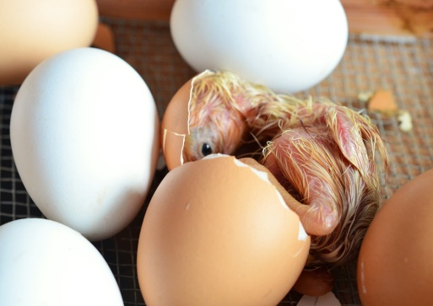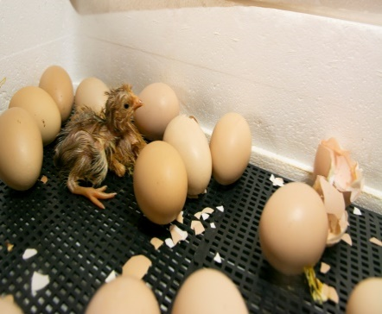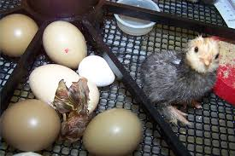
Figure 4.8 Images of spoilt eggs in a hatcher in Mwezi Solar farm
Using these data, the variables investigated in the study were determined using Erensayın, (2000) equation 4.1 in which H_{a} is hatchability, N_{ea} is number of eggs hatched, and N_{et} are the total number of eggs in the incubator
$H_{a}(\%)=100\frac{N_{eh}}{N_{et}}$……………………………………………………………………4.1
The results of the spoilt eggs indicates that the chicks were fully developed but failed to crack the egg shell and this drastically reduced hatchability,
The controlled experiment yielded hatchability of 87.5 and 78.1% of the eggs stocked. The results are illustrated in Table B4.10 in the appendices.
Water depth in the evaporating pan determines the rate of evaporation of moisture within the incubating chamber; Rose et al., (2005) states that higher the depth of water the less effective is the water evaporation. The results obtained in this study are shown in Figure 4.9. The results show that as water depth increases relative humidity increases linearly, with a coefficient of determination R² of 0. 8395.This indicates that a strong positive relationship exists between the relative humidity and the water depth in the incubator with an intercept of 29.76. Figure 4.8 and Table B4.11 in the appendices shows the respective raw data.

Figure 4.9 Relation between relative humidity and water depth of the incubator

One-way ANOVA with 5% significance (α = 0.05) and their corresponding F _{Critical} values were used to determine the validity of hypothesis, whether there existed an observable difference among the means of the firms. Table 4.12 presents the ANOVA results. The results showed that the F-actual value was 758.788 which is greater than F- critical value of 2.557, the larger the F- ratio, the greater is the difference between the groups as compared within the groups, F- ratio equal to or less than 1 indicate that there is no significant difference between the groups and the null hypothesis is correct, If the null hypothesis is small then it can be concluded that the independent variable did not have an effect on the dependent variable, Kothari, 2004 noted that the lower the RMSE the better is the performance of the machine and vice versa.

Table 4.12: ANOVA table
 |  |  |  | Percentage hatchability |  |  |  |  |  |  |  |  |  | SStotal
 |  | Maningi |  | 79.2 | 78.2609 |  |  | 81.94 |  | 78.92 |  | 74.68 |  | 46983
 |  | Sidindi |  | 61 | 60.6227 |  |  | 60 |  | 54.76 |  | 31.98 |  | 74834.3
 |  | Obwombe |  | 52.7 | 75 |  |  | 72.10 |  | 70.14 |  | 82.00 |  | 55722.5
 |  | Wagai |  | 37.2 | 36.98 |  |  | 42.59 |  | 70.66 |  | 73.33 |  | 77413.6
 |  | Mwezi solar |  | 67.7 | 47.69 |  |  | 74.53 |  | 73.84 |  | 48.99 |  | 64500.2
 |  | Omuma |  | 3.7 | 48.38 |  |  | 60.8 |  | 51.69 |  | 42.12 |  | 91959.6
 |  | Blood sister |  | 36.5 | 43.14 |  |  | 57.22 |  | 33.33 |  | 37.06 |  | 90211.3
 |  | Spio |  | 67.7 | 62.72 |  |  | 63.16 |  | 67.89 |  | 70.43 |  | 59578.6
 |  | Dala Riek |  | 57.4 | 57.30 |  |  | 58.08 |  | 70.80 |  | 54.40 |  | 67350.5
 |  | Dijos |  | 36.5 | 64.49 |  |  | 44.07 |  | 48.38 |  | 46.85 |  | 81642.7
 |  | Maugo |  | 19.8 | 51.68 |  |  | 55.55 |  | 53.81 |  | 65.92 |  | 80780.3
 |  | Mean |  | 47.2 | 56.93 |  |  | 60.91 |  | 61.29 |  | 57.0728 |  | 790977
 |  | Sswithin |  | 5159 | 1660.03 |  |  | 1428.97 |  | 1907.73 |  | 2882.77 |  | 13038.9
 |  | Degree of freedom between=4
 |  | degree of freedom within 50
 |  | degree of freedom total = 54
 |  | F- critical = 2.557
Grand mean = 175.511
SStotal =790977
 |  | SSwithin=13038.9
 |  | SS_{between} =777938
mean Square between =194485
Mean square within = 260.778
F - actual = 758.788
According to Kothari (2004), when F-actual is greater than F- critical, then there is a significant difference between the groups, this indicates that water depth in the water pan, temperature and relative humidity affects the hatchability percentage of eggs stocked in an incubator. The above analysis indicates that the performance of hatching systems in Siaya County is very low and this necessitates for modification for achievement of optimal conditions for higher hatchability.

4.6 Performance of Modified Hatching Systems
4.6.1 Setter tray turning angle
Egg turning mechanism facilitates the absorption of the albumen by the embryo and prevents the embryo from adhering to the shell membrane. Studies have shown that failure to turn eggs can lower hatching rates by as much as 50 % (Poultry Sci. 2005). It allows the diffusion of gases inside the eggs and between the eggs and the external environment and is critical during the first week of incubation, due to the long distance between the embryo and the shell and to the high albumen density. The embryo depends on the diffusion of gases through the eggshell and the albumen to obtain O₂ and eliminate CO₂, because the embryo develops on the yolk surface and gases are exchanged directly by the embryonic cells (Boleli et al 2016). The setter tray angle was set at 45º.Johnson Level & Tool 1886-0200 Professional Magnetic Digital Angle Locator was used to measure the turning angle of the machines as shown in Figure 4.9. The results of the angles obtained are presented in Table 4.13.
Table 4.13: Egg turning angle
Firm | Mwezi solar | omuma | blood sister
Angle of turn(degrees) | 38 | 30 | 35

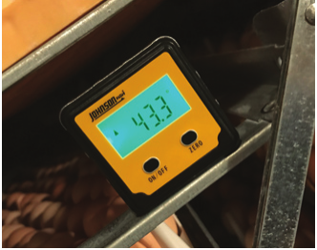

Figure 4.10 Determination of turning angle of egg incubator machines

According to Cutchin et al., (2009) eggs turned less than 40° reduces hatchability and chick quality which also increase embryonic mortality and malposition. All the firms’ setter trays were set between 38º, 30º and 35º, with a deviation of 5º,13º and 8º respectively from the minimum recommended turning angle. Elibol and Braket (2006), recommended angle that best fits the operational conditions of commercial setters ranges between 43º to 45º. Moreover, Tona et al., (2005) reported that egg turning is required during incubation until day 15 with a turning frequency of one hour for a full turn and 5 minutes for a level period.

4.6.2 Hatchability of Hatcheries after Modification
The performance results of the modified incubators for the three firms show that the hatchability was higher with average values being 95.08%, 94.89% and 95.88% for Firm 1, Firm 2 and Firm 3 (Figure 4.10) respectively. The corresponding RMSE were 5.11, 2.254 and 1.79 respectively presenting a marginal fail. Table B4.14 in the appendix shows the results of hatchability after modification, in which the RMSE were 29.9, 58.12 and 55.12 respectively with mean hatchability percentages of 62.55%, 41.34% and 41.52% respectively before modification. This agrees with the recommendations of Ali (2022) and Benjamin, N. & Oye, (2012) that for better performance of egg incubator machines, the parameters of temperature, water depth in the water pan, relative humidity, turning angle of eggs in the machines and ventilation should be routinely checked after every stocking to ensure that optimal measurements are achieved to avoid poor and low hatchability.

Figure 4.11 Hatchability of hatchery systems after modification
Furthermore, the second and third batches of a controlled experiment yielded 100% of the eggs stocked for two batches incubated as shown in Table B4.15 in the appendix kindling was done on day 1 and 7 as shown in Figure 4.11 and 4. 12.

Figure 4.12 kindling process
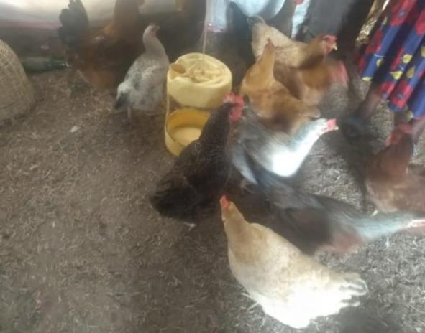

Figure 4.13 Cock to hen ratio

4.3.3 Moisture Regulation Mathematical Model
Kaye and Laby (2017) state that at a 5% significance level, relative humidity does not account for the variation in temperature differences. This is because the moisture in air is composed of water vapor, not liquid water, and has a thermal conductivity of 0.017 W/(mK) at 37.8°C. Van Brecht et al. (2003) further notes that the heat transfer coefficient mainly depends on the thermal conductivity of air, which ranges from 0.03 to 0.08 W/(mK), aligning with findings by Indaver (2005). They concluded that the total mass of water vapor in moist air is low, making its thermal conductivity nearly identical to that of dry air. This similarity explains why moist air humidity has a minimal effect on the heat transfer coefficient.
To verify if this impact is indeed negligible, a confidence interval was calculated using equation 4.1.
CI = X ± t*_{df, α/2}× SE……………………………………………………………………4.1
From Table 4.13, the error is 1.7; t-value from the table is 2.604
CI₁=29.76+2.6*1.7 =34.18
CI₂=29.76- 2.6*1.7 = 25.34
Therefore, the intercept cannot be taken to be zero since CI₁ and CI₂ are 34.18 and 25.34 respectively. The values of b and c in equation 3.2 are 0.14 and -0.17 respectively, values are all less than 0.5 which means all the factors are significant and can be used in the equation. Therefore, the model for determining the correct depth of water in egg incubators is given by equation 4.2.
Y= a + 0.14x₁ – 0.17x₂................................................................................................4.2
The model has R² value of 0.835; hence this model can be used to determine the required volume of water to be added in water pan every 24 hours. The evaporation rate was determined by the difference in water depth in a 24-hour cycle of incubation replicated three times using the equation 4.3 and the results are as shown in Table B4.16 and B4.17.
Rate of evaporation = (D₁-D₂)/24 cm/hr.…………….…………………………………4.3
Where D₁ = initial depth in cm
D₂ = depth after 24 hours in cm
Depth of water that evaporates per hour = 2.25/24
= 0.09375 cm/hr
= 0.000935 m/hr
= 9.35*10⁻⁴ m/hr
Surface area of water pan = 0.3*0.3 = 0.09 m²
Volume of moisture that evaporates in 1 hour = 0.000935*0.09 = 8.415*10⁻⁵ m³/hr
Volume of water required after 24 hours = 8.415*10⁻⁵ m³/hr*24
= 2.0*10⁻³m³
= 2 litres
To facilitate adequate evaporation of water, optimal water depth is essential after every 8 hours with a volume of 0.7 litres with a depth of;
0.7 litres/1000 = 0.3*0.3*H
H = 0.0007/0.09
= 0.0078 m
= 0.78 cm
The results agree with Gualhanone et al., 2012, Hulet et al., (2007) who recommended that for effective evaporation rate, the water depth to be thinner.

CHAPTER FIVE

CONCLUSIONS AND RECOMMENDATIONS

5.1 Conclusion
The following conclusions were drawn;
- The improved indigenous chicken breeds reared in Siaya County are Sasso kuroiler, Kenbro and KALRO improved chicken. The cock to hen ratio is 1:3 to 1:6 in a free-range system while 1:7 in an enclosed system and the average management practices of the breeding stocks fell outside the standard hatchery management practices.
- Hatcheries in Siaya County attained percentage hatch of 56% which is below the recommended hatching percentage of 94%. The low hatching percentage is largely caused by poor management of incubation moisture that leads to low Relative Humidity in the incubation chamber.
- Modification of hatching systems by moderating RH to be within the recommended range, improved the hatching percentage to 95.28%. Therefore, performance of hatcheries can be enhanced by optimizing the RH, temperature and breeding stock characteristics, handling and storage of eggs.

5.2 Recommendations
5.2.1 Recommendations from the study
Moisture management in the incubating space should be regulated by filling the water pan with 0.7 litres of water after every 8 hours with a depth of 0.78cm for a pan measuring 0.3m*0.3m for effective evaporation and maintenance of Relative Humidity within the acceptable range.

5.2.2 Recommendations for Further Study
The study was confined to evaluate the effectiveness of performance of small-scale indigenous chicken hatching systems in Siaya County, Kenya. The study therefore recommends further studies on the following areas;
- A study on the impact of one degree change on the turning angle of egg incubators on hatchability.
- A study on development of a mathematical model that can be used to predict the percentage hatchability of eggs in an incubator

REFERENCES
Amanda, R., & Victor, L. W. (2017). Basic and advanced statistical tests. Springer, 13-16 p. https://doi.org/10.1007/978-94-6351-086-8_3
Asghar, G., & Saleh, Z. (2012). Normality tests for statistical analysis: A guide for non-statisticians. International Journal of Endocrinology Metabolism, 10(2), 486-489. https://doi.org/10.5812/ijem.3505
Boleli, I. C., Morita, V. S., Matos, J. B., Thimotheo, M., & Almeida, V. R. (2016). Poultry egg incubation: Integrating and optimizing production efficiency. Brazilian Journal of Poultry Science, 18(2), 1-16.
Bolla, G. (2007). Small-scale poultry keeping – Brooding and rearing chickens. Retrieved from www.dpi.nsw.gov.au/primefacts
Bolaji, B. O. (2008). Design and performance evaluation of a solar poultry egg incubator. Thammasat International Journal of Science and Technology, 13(1), 47-55.
Carla, (2013). Effect of relative humidity during incubation at a set eggshell temperature and brooding temperature post-hatch on embryonic mortality and chick quality.
Divoky, G. J., & Harter, B. B. (2010). Supernormal delay in hatching, embryo cold tolerance, and egg-fostering in the black guillemot Cepphus gryille. Marine Ornithology, 38, 7-10.
E. H., & Carol, B. (2008). Publishing nutrition research: A review of non-parametric methods, part 3. Journal of the Academy of Nutrition and Dietetics, 108(9), 1488-1496. https://doi.org/10.1016/j.jada.2008.06.42
Emilia. (2022). The effects of hen's age and egg storage duration on selected growth parameters of turkey embryo. https://doi.org/10.1016/j.psj.2022.102301
Fairchild, B. (2012). Environmental factors to control when brooding chicks. GA Cooperative Extension Bulletin 1287.
Fatih, O. (2020). Parametric or non-parametric: Skewness to test normality for mean comparison. International Journal of Assessment Tools in Education, 7(2), 255-265.
Francis, S. N. (2016). Nonparametric statistical tests for the continuous data: The basic concept and the practical use. Korean Journal of Anesthesiology, 69(1), 8-14. https://doi.org/10.4097/kjae.
Gbabo, A., Liberty, J. T., Gunre, O. N., & Owa, G. J. (2014). Modeling incubation temperature: The effect of incubator design, embryonic development, and egg size. Poultry Science, 76.
Habbib, (2009). Energy consumption for poultry egg incubator to suit small farmers; Agricultural Engineering Research Institute, ARC, Dokki, Giza (Manuscript received 10 November 2009).
Hammond, C. L., Simbi, B. H., & Stickland, N. C. (2007). In ovo temperature manipulation influences embryonic motility and growth of limb tissues in the chick (Gallus gallus). The Journal of Experimental Biology, 210, 2667-2675.
Hollander, M., & Wolfe, D. A. (1999). Nonparametric statistical methods (2nd ed.). Wiley.
Iqbal, J., Khan, S. H., Mukhtar, N., Ahmed, T., & Pasha, R. A. (2014). Design, construction and performance evaluation of an electric powered egg incubator. International Journal of Research in Engineering and Technology, 3, 521-526.
Irtwange, S. V. (2003). Effects of egg size (weight) and age on hatching performance and chick quality of broiler breeder. Journal of Applied Animal Research, 44(1), 54-64.
J. P., & Abdel-Salam, G. (2019). Testing statistical assumptions in research. Hoboken, New Jersey, 141-174 p. https://doi.org/10.1002/978111952838
J. B. Gaughan. (2009). Response of domestic animals to climate challenges.
Kalubarme, P., Jambhale, P., Adate, P., & Pawar, P. (2018). Passive solar poultry eggs incubator: II development and preliminary performance evaluation. Journal of Applied Science, Engineering and Technology, 3(2), 30-36.
Kamau, C. N., Kabuage, L. W., & Bett, E. K. (2019). Analysis of improved indigenous chicken adoption among smallholder farmers: Case of Makueni and Kakamega counties, Kenya. International Journal of Agricultural Extension, 7(1), 21-37.
King'ori, A. M. (2011). Review of the factors that influence egg fertility and hatchability in poultry. International Journal of Poultry Science, 10(6), 483-492.
Kuye, S. I., Adekunle, N. O., Adetunji, O. R., & Olaleye, D. O. (2007). Review of the factors that influence egg fertility and hatchability in poultry. International Journal of Poultry Science, 10(6).
Mansaray, K. G., & Yansaneh, O. (2015). Fabrication and performance evaluation of a solar powered chicken egg incubator.
M. J. W., Meijerhof, R., & Van den Brand, H. (2013). International Journal of Emerging Technology and Advanced Engineering, 5(6), 31-36.
Morita, V. (2016). Poultry egg incubation: Integrating and optimizing production efficiency.
Nizam, A. (2001). Anizam Agro Farm Enterprise - Pembuat Incubator Sejak 1996.
Ochieng, J., Owuor, G., Bebe, B. O., & Ochieng, D. O. (2011). Effect of management interventions on productive performance of indigenous chicken in Western Kenya.
Onono, J. O., Pablo, A., Maurice, K., Patrick, M., James, M. A., Carron, M., Eric, M. F., Barbara, H., & Jonathan, R. (2017). Identification of production challenges and benefits using value chain mapping of egg food systems in Nairobi, Kenya. Agricultural Systems, 159, 1-8. https://doi.org/10.1016/j.agsy.2017.10.001
Otecko, N. O., Ogali, I., Nganga, S. I. N., Mauki, D. H., Oganda, S., Moraa, G. K., Lichoti, J., Agwanda, B., Min-Shen, P., Sheila, C. O., & Ya-Ping, Z. (2019). Phenotypic and morphometric differentiation of indigenous chickens from Kenya and other tropical countries augments perspectives for genetic resource improvement and conservation. Poultry Science, 98(7), 2747-2755. https://doi.org/10.3382/ps/pez097
Onsongo, V. O., Osuga, I. M., Gachuiri, C. K., Wachira, A. M., Miano, D. M., Tanga, C. M., Ekesi, S., Nakimbugwe, D., & Fiaboe, K. K. M. (2018). Insects for income generation through animal feed: Effect of dietary replacement of soybean and fish meal with black soldier fly meal on broiler growth and economic performance. Journal of Economic Entomology, 111(4), 1966-1973.
Omondi, S. O. (2022). Poultry value chain in two medium-sized cities in Kenya: Insights from cluster theory. Frontiers in Veterinary Science, 9, 601299. https://doi.org/10.3389/fvets.2022.601299
Pius, L. O., Strausz, P., & Kusza, S. (2021). Overview of poultry management as a key factor for solving food and nutritional security with a special focus on chicken breeding in East African countries. Biology, 10(8), 810. https://doi.org/10.3390/biology10080810
Resnick, D., & Holliday, S. (1992). Incubator designs.
Servet, K. (2022). Incubation temperature and lighting: Effect on embryonic development, post-hatch growth, and adaptive response. https://doi.org/10.3389/fphys.

APPENDICES

Appendix I: Characterization of breeding stocks
Table A4.1: Breeding stock characteristics
Parameter/Farms | Maningi | Sidindi | Obwombe | Wagai | Mwezi solar
No of hens | 1400 | 205 | 1800 | 600 | 300
No.of cocks | 200 | 47 | 260 | 200 | 62
Age of cocks(weeks) Max | 96 | 240 | 96 | 100 | 192
Min | 36 | 16 | 20 | 32 | 19
Age of hens(weeks) Max | 104 | 144 | 72 | 144 | 148
Min | 24 | 20 | 28 | 16 | 20

Omuma | blood sister | spio | Dala Riek | Dijos | Maugo
156 | 220 | 567 | 708 | 252 | 342
25 | 31 | 79 | 139 | 38 | 50
144 | 176 | 60 | 112 | 148 | 138
34 | 24 | 24 | 36 | 16 | 23
90 | 132 | 88 | 64 | 120 | 144
23 | 20 | 24 | 32 | 28 | 26

Table A4.2: Cocks to hens’ ratios
Parameter/Farms | Maningi | Sidindi | Obwombe | Wagai | Mwezi solar
Cock to hen’s ratio | 1:7 | 1:4 | 1:7 | 1:3 | 1:5

Omuma | Blood sister | Spio | Dala Riek | Dijos | Maugo
1:6 | 1:7 | 1:7 | 1:5 | 1:7 | 1:7

Table A4.3: Handling and storage of eggs characteristics
Parameter/Farms |  |  |  | Maningi |  | Sidindi | Obwombe | Wagai | Mwezi solar
Duration of storage(days) |  |  |  | 5 |  | 10 | 10 | 10 | 10
% Dirt covered |  |  |  | 3 |  | 12 | 5 | 5 | 15
Egg length (mm) min |  |  |  | 52 |  | 45 | 49 | 44 | 51
max |  |  |  | 61 |  | 59 | 62 | 57 | 59
Egg tray weight (g) |  |  |  | 1800 |  | 2040 | 1895 | 1805 | 1780
Omuna | Blood sister | Spio | Dala Riek
10 | 10 | 10 | 10
4 | 10 | 5 | 2
46 | 44 | 45 | 42
63 | 58 | 61 | 59
2145 | 1600 | 1710 | 1560

Appendix II: Performance of hatcheries
Table B4.6: Spoilt Eggs
characteristics of spoilt eggs after 24 days
Farm Enterprise | Number of eggs spoilt | Sample size | Rotten | Dead Chicks | Live chicks but could not crack
Maningi | 633 | 315 | 25 | 176 | 114
Mwezi Solar | 342 | 170 | 18 | 133 | 19
Omuma | 470 | 234 | 23 | 169 | 42
Blood sister | 545 | 271 | 13 | 205 | 53

Table B4.7: Spoilt eggs from each layer
Hatchery | Capacity | No. of entry stocks | No. of eggs stocked | No. of eggs hatched | No. of eggs spoilt | No.of eggs spoilt per Layer
 |  |  |  |  |  | Top | Middle | Bottom
Mwezi solar | 700
 |  | 6 | 700 | 377 | 323 | 57 | 182 | 84
Omuma | 540
 |  | 6 | 540 | 169 | 371 | 200 | 123 | 48
Blood sister | 540
 |  | 6 | 540 | 275 | 265 | 61 | 135 | 69

Table B4.8: Features of spoilt eggs
Mwezi solar 700 Egg capacity
layers | Eggs Spoilt | Rotten | Dead Chicks | Live chicks but could not crack
Top | 28 | 2 | 15 | 11
middle | 90 | 8 | 53 | 29
bottom | 41 | 7 | 8 | 26
Omuma 540 Egg capacity
layers | Eggs Spoilt | Rotten | Dead Chicks | Live chicks but could not crack
Top | 99 | 13 | 59 | 27
middle | 60 | 4 | 43 | 13
bottom | 23 | 2 | 11 | 10
Blood sister 540 Egg capacity
layers | Eggs Spoilt | Rotten | Dead Chicks | Live chicks but could not crack
Top | 29 | 2 | 18 | 9
middle | 66 | 5 | 21 | 40
bottom | 33 | 1 | 16 | 16

Table B4.10: Hatchability under controlled experiment
 | Eggs stocked | Hatched Eggs | Unhatched eggs | % Hatchability
1st Batch | 128 | 112 | 16 | 87.5
2nd Batch | 120 | 100 | 20 | 78.1

Table B4.11: Water depth and Relative Humidity Regression analysis
 | Coefficients | Standard Error | t Stat | P-value | Lower 95% | Upper 95% | Lower 95.0% | Upper 95.0%
Intercept | 29.76 | 11.41 | 2.60 | 0.047 | 0.425 | 59.107 | 0.425 | 59.10
RH | 0.147 | 0.203 | 0.725 | 0.500 | -0.3752 | 0.670 | -0.375 | 0.670
Depth | -0.1708 | 0.278 | -0.6133 | 0.566 | -0.887 | 0.5453 | -0.887 | 0.545

Table B4.15: Hatchability under controlled experiment
 | Eggs stocked | Hatched Eggs | Unhatched eggs | % Hatchability
1st Batch | 128 | 128 | 0 | 100
2nd Batch | 100 | 100 | 0 | 100

Table B4.14: Stocking Hatchability Rating after Modification
Hatchery | A | B | C | D | E | F | G | H | I | J | K
Mwezi solar | 700
 |  | 1 | 700 | 661 | 39 | 94 |  | 4.42 | 19
 |  | 2 | 673 | 645 | 28 | 96 | 90+% | 5.83 | 34 | 5.11 | 95.08
 |  | 3 | 698 | 663 | 35 | 95 |  | 4.99 | 24
Omuna | 540
 |  | 1 | 540 | 519 | 21 | 96 |  | 0.11 | 0
 |  | 2 | 532 | 513 | 19 | 96 | 96+% | -0.4 | 0 | 2.2 | 94.69
 |  | 3 | 470 | 433 | 37 | 92 |  | -3.9 | 15
Blood sister | 540
 |  | 1 | 540 | 526 | 14 | 97 |  | 1.41 | 2
 |  | 2 | 498 | 465 | 33 | 93 | 96+% | -2.6 | 6 | 1.7 | 95.88
 |  | 3 | 540 | 523 | 17 | 97 |  | 0.85 | 0
Key
A=Capacity
B=Number of entry stocks
C=Number of eggs stocked
D=Number of eggs hatched
E=No. of eggs spoilt
F= % hatchability
G=Manufacturers rating
H=Deviation from mean
I=Error
J=RMSE
K=Mean hatchability %

Table B4.16: Relative Humidity, water depth and temperature values
RH | Water depth(cm) | TEMP (degree Celsius)
56.5 | 2.1 | 37.1
59.9 | 4 | 37.7
59.5 | 4.1 | 37.6
62 | 5.9 | 37.7
61.5 | 5.2 | 38.1
60 | 4.8 | 38.1
60.5 | 4 | 38.5
62 | 5.1 | 38.1
61 | 4.1 | 37.8

Table B4.17: Depth water levels in the water pan
Depth(cm) | Average depth values
D1 | 7.1 | 5.6 | 5 | 8 | 7 | 9 | 4.8 | 5.3 | 4.7
D2 | 5.1 | 3.6 | 3.1 | 5.9 | 4.6 | 6.1 | 3.1 | 2.5 | 2.2

Appendix III: Siaya County agrovets’ research questionnaire
This questionnaire is intended to collect data to assist a Masters student at the University of Eldoret in Kenya who is carrying out research on the ‘Effectiveness of Smallholder Indigenous chicken hatching system in Siaya County’ to complete his postgraduate studies. Your responses will be of great help to him.
- Tick in the appropriate section your responses
1. How long have you operated your Agrovet business in Siaya County
- Less than one year
- More than one year
2. Which poultry vaccines are commonly purchased by farmers within your business reach in Siaya County
- NCD
- Gumboro
- Fowl pox
- Fowl typhoid
- Deworming
- Other vaccines

Appendix IV: Similarity Report
